**MAJOR PROJECT**

**Project Overview:**

To develop the System to analyze the log data (In XML format) of government progress of various development activities.

**Purpose and Scope of this Specification:**

The purpose of this project is to capture the data for analyzing the progress of various activities.

**In scope:**

The following requirement will be addressed in phase 1 of Project:

* Developing system to handle the incoming log feed and store the information in Hadoop Cluster (Flume)
* Analyze the data and understand the progress
* Store the results in Hbase/RDBMS

**Out of scope**:

* We can use this data and visualization and get more insights

**Product/Service Description:**

**Assumptions:**

Log will be generated in XML format and stored in a server.

**Constraints:**

Describe any item that will constrain the design options, including

* This system may not be used for searching for now. But it will be used for analysis and saving the relevant information as of now.
* System will be using Hbase as a database.

**Requirements:**

* The FLUME job which will format the data and place the data to HDFS

* Pig/MapReduce job for parsing the XML data.
* Create Pig scripts/MapReduce jobs to analyze the data
* Create the Sqoop job to store the data in database

**Priority Definitions:**

The following definitions are intended as a guideline to prioritize requirements.

* **Priority 1** – Create FLUME job for fetching log files from spool directory the data
* **Priority 2** – MapReduce/pig job to preprocess

**Input Data Set:**

<https://drive.google.com/file/d/0Bxr27gVaXO5sUjd2RWFQS3hQQUE/view?usp=sharing>

**Downloading Data set Local System:**

The following process is done to download the data set into the local file system:

First the Virtual box is opened and the JPS command is run to start the NameNode, DataNode, JobTracker and TaskTracker in Hadoop.

Then the directory is created to save the Input Data Set.

Name of the directory is flume_import.

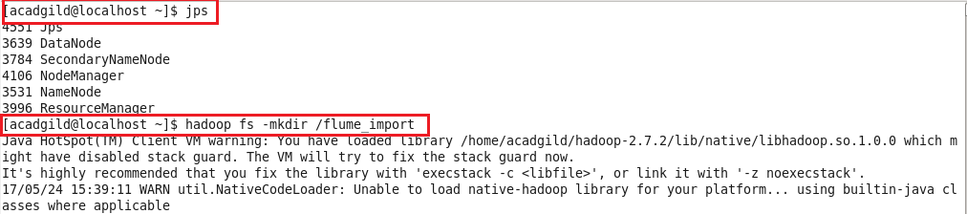

**Copying the dataset from local system to HDFS using FLUME:**

The following steps are executed to copy the dataset from LocalSystem to HDFS

**The conf file is downloaded and used to configure FLUME for copying the data set from localsystem to HDFS**

**The configuration command is as follows:**

agent1.sources = mysrc

agent1.sinks = hdfsdest

agent1.channels = mychannel

agent1.sources.mysrc.type = exec

agent1.sources.mysrc.command = hadoop dfs -put /home/acadgild/StatewiseDistrictwisePhysicalProgress.xml /flume_import

agent1.sinks.hdfsdest.type = hdfs

agent1.sinks.hdfsdest.hdfs.path = hdfs://localhost:9000/flume_import

agent1.channels.mychannel.type = memory

agent1.sources.mysrc.channels = mychannel

agent1.sinks.hdfsdest.channel = mychannel

**Step 1: The following FLUME command is used to copy the dataset from LocalSystem to HDFS:**

**FLUME command:**

flume-ng agent agent1 –n agent1 –f /home/acadgild/apache-flume-1.6.0-bin/conf/majproj.conf

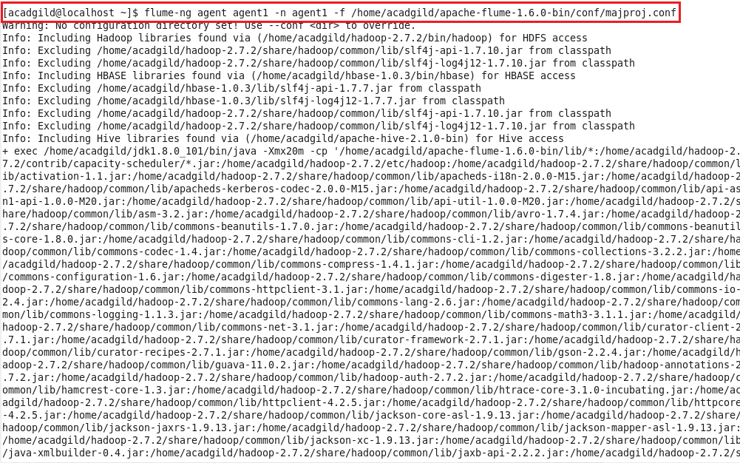

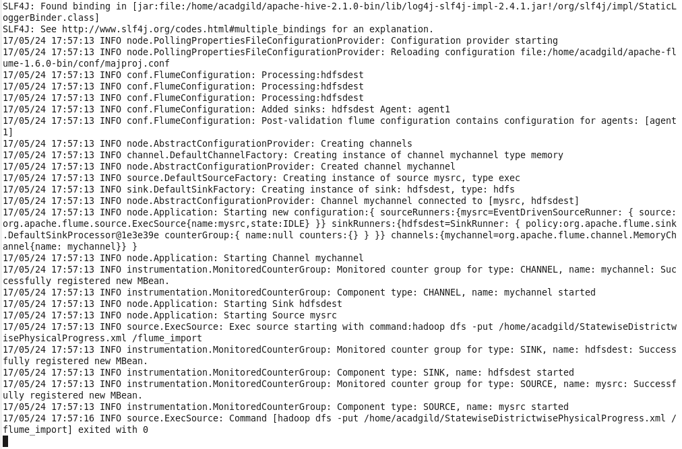

The command is executed and the data set is copied from LocalSystem to HDFS using FLUME command.

**The following steps show that the dataset is present in HDFS:**

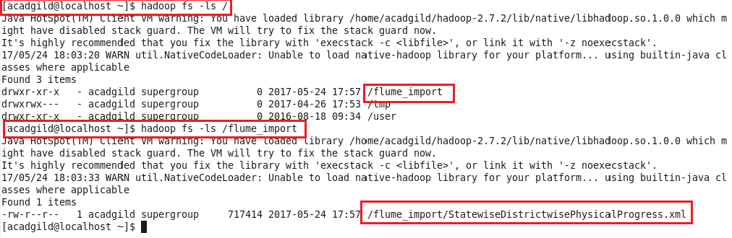

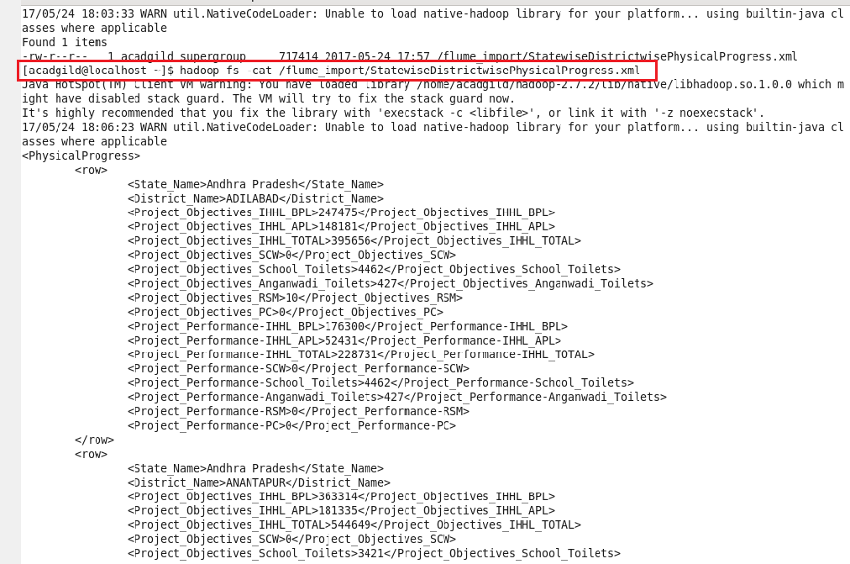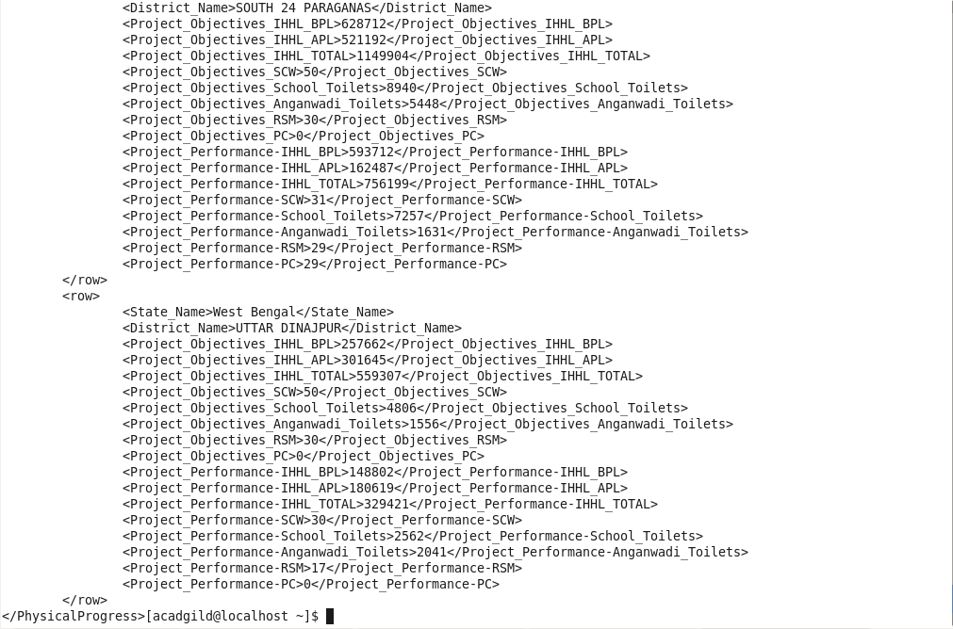

Since the data is very large, only the beginning and ending of the fetched results are attached.

**Step 2: Conversion of XML format Input Data into CSV format:**

The objective of copying the data set from localsystem to HDFS is because the format of the original data set is in XML format and it is converted into CSV format to reduce the complexity of the data set and the fetched solutions.

The conversion of the input data from XML format to CSV format is done as follows:

* The Pig script is written as Shell Scripting to reduce the complexity of process involved.
* The pig script is run in the terminal.

**Pig Script:**

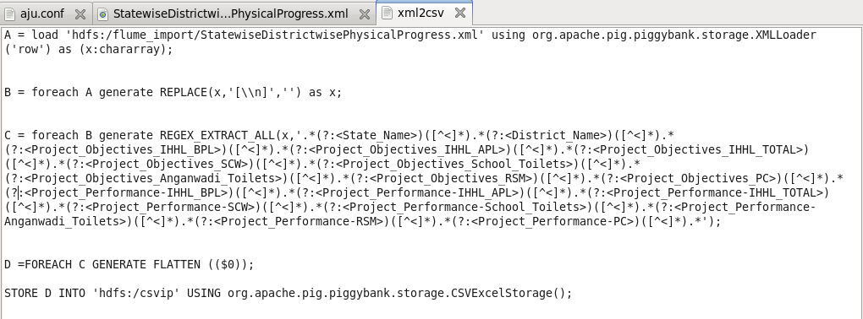

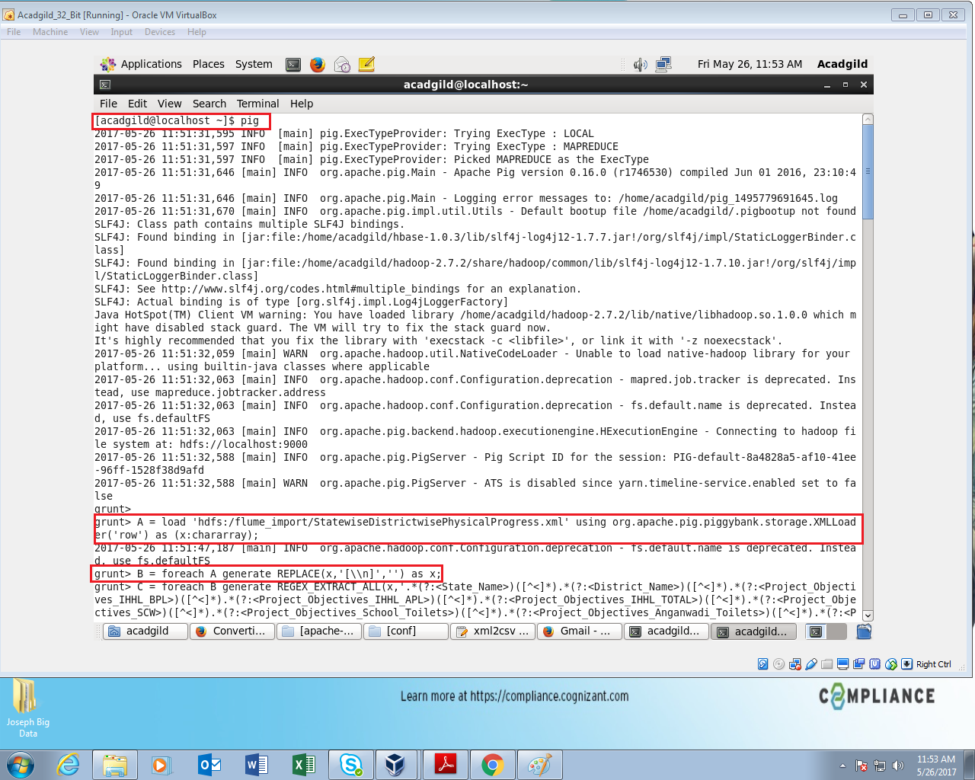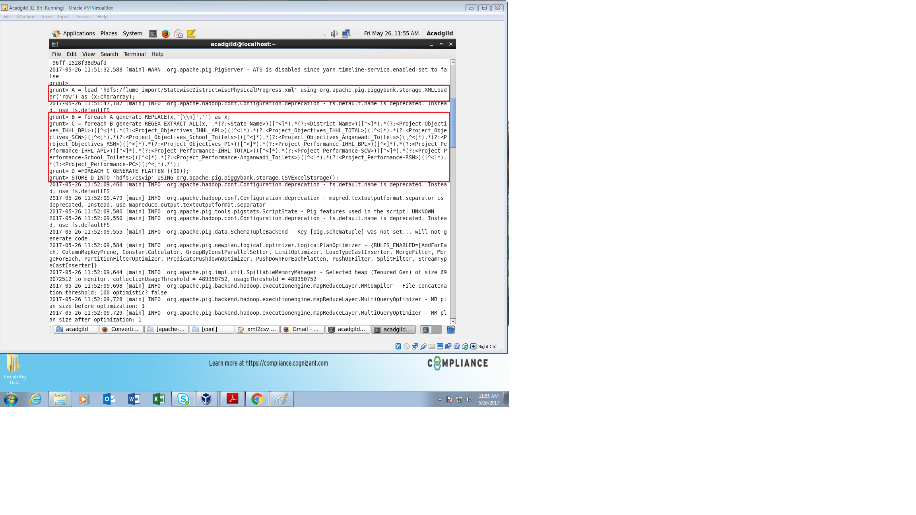

After successfully running the pig script, the input data is checked by the following steps

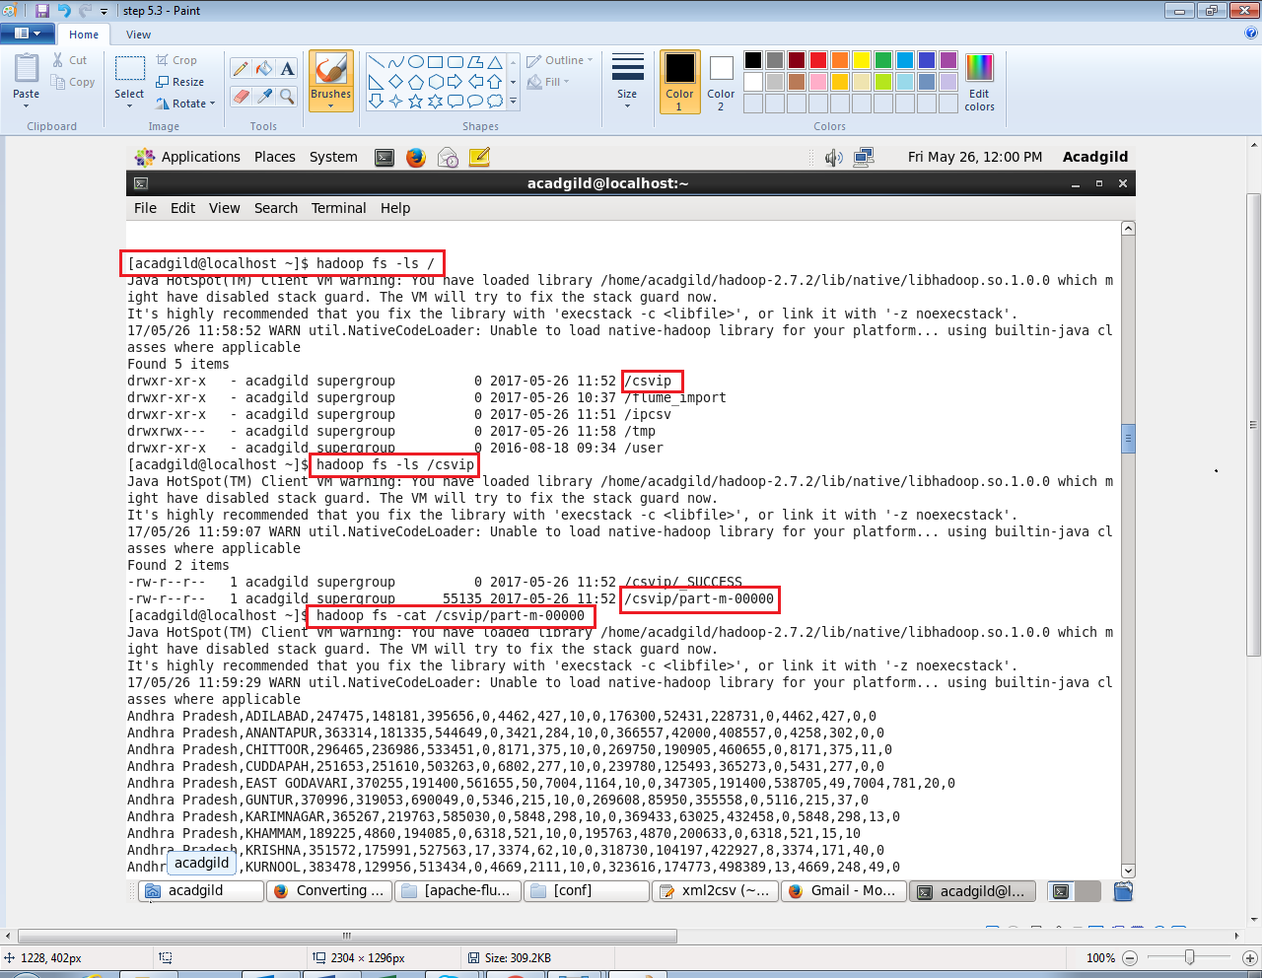

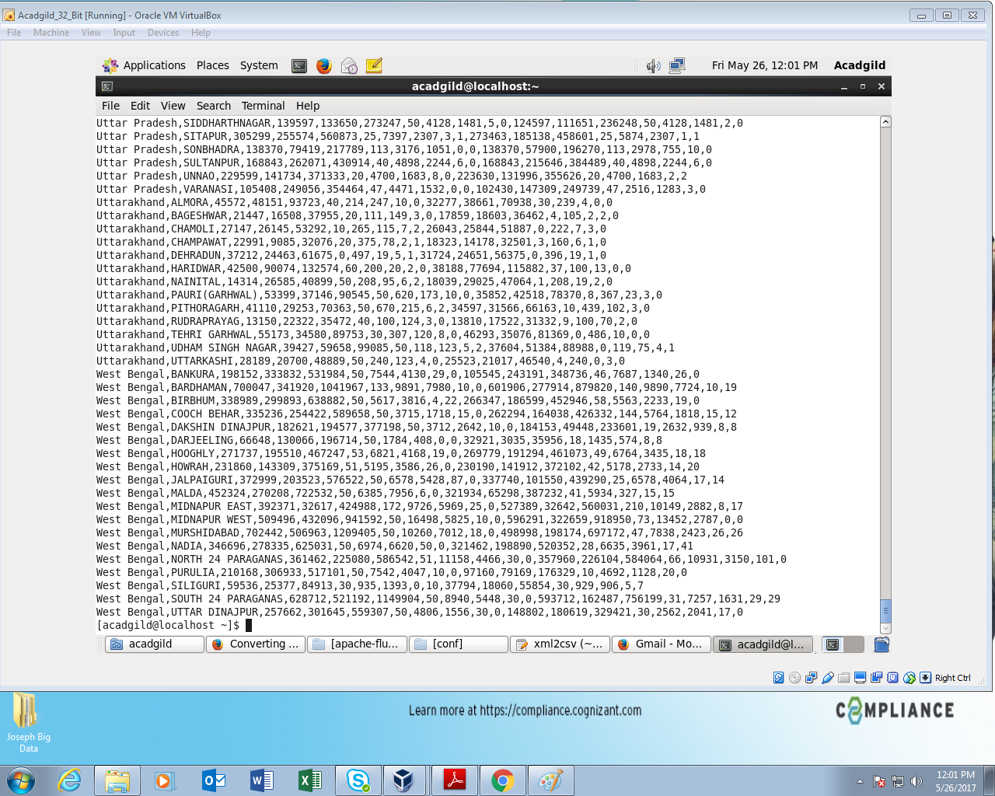

Since the data is very large, only the ending of the fetched results are attached.

Hence the original data set which is in XML format has been converted into CSV format in order to reduce the complexity of the Data set for the users.

**Problem statement:**

* Find out the districts who achieved 100 percent objective in BPL cards Export the results to mysql using sqoop.
* Write a Pig UDF to filter the districts which have reached 80% of objectives of BPL cards. Export the results to MySQL using Sqoop.

**Problem Statement 1:**

* Find out the districts who achieved 100 percent objective in BPL cards.
* Export the results to mysql using sqoop.

**Solution:**

The requirement for the problem statement is to find which districts have achieved 100 percent objective in BPL cards and the achieved result should be exported to mysql using SQOOP.

The program is written in PigScript using Shell Scripting methods for easy understanding and to reduce the complexity of programming which occurs in MapReduce programming.

**PigScript:**

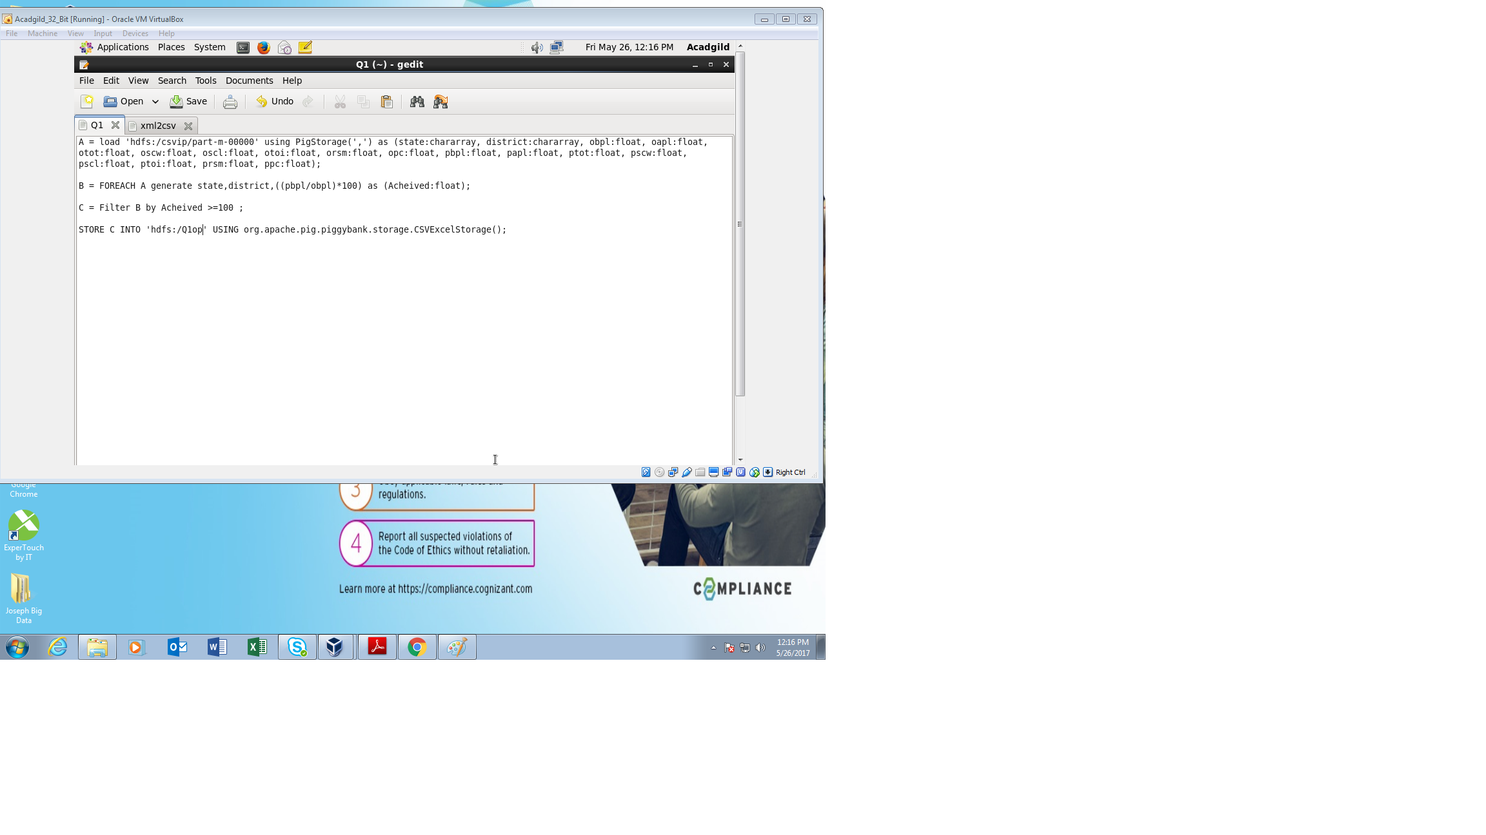

**The PigScript is explained as follows:**

**Step A:**

The part file of the input is loaded using PigStorage and the dataset is separated by comma ( , ). The data set is defined in this step based on the input given and output required.

**Step B:**

From the problem statement, it is required to calculate the percentage of the required dataset.

Hence the required columns are taken and the percentage is calculated for all the records for the given columns taken.

**Step C:**

As given in the problem statement, the requirement is that those districts which have achieved 100%.

Hence the result from Step B is filtered according to the requirements.

Finally, the result from Step C is stored into HDFS under the file Q1op.

After the PigScript is completed, the Pigscript is run in the terminal by following sequence

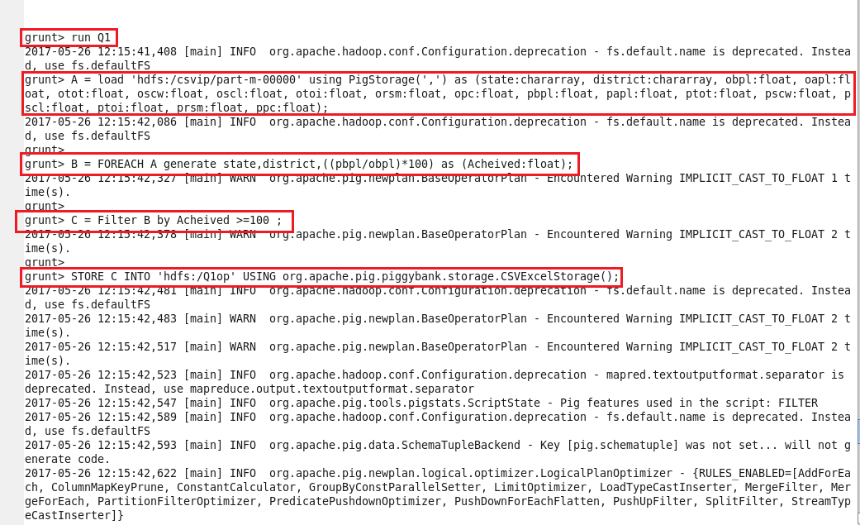

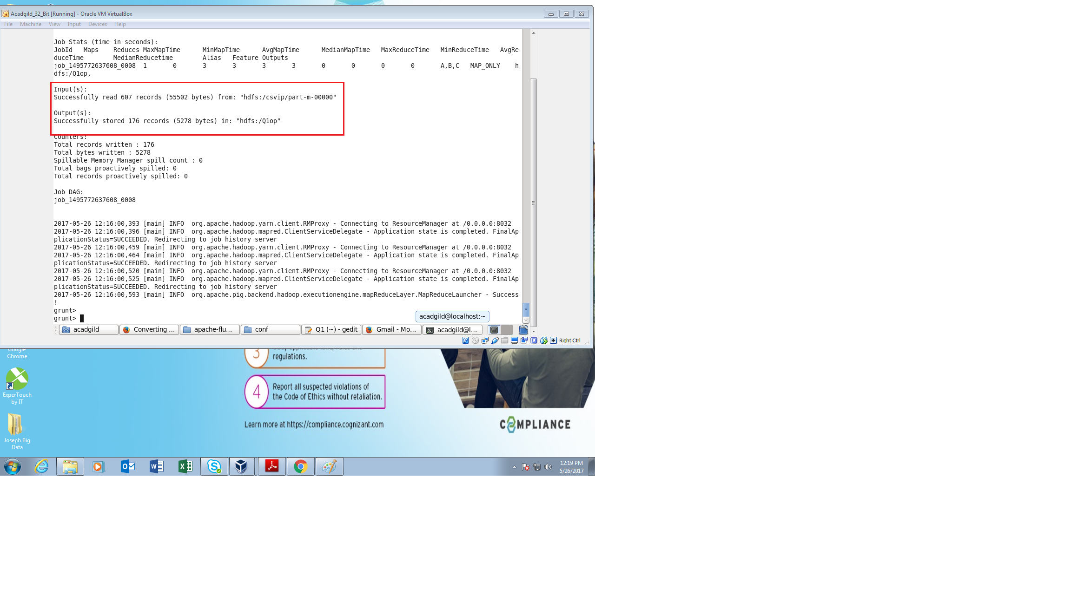

After successfully running the PigScript, The following steps are executed to check if the data set is present in HDFS

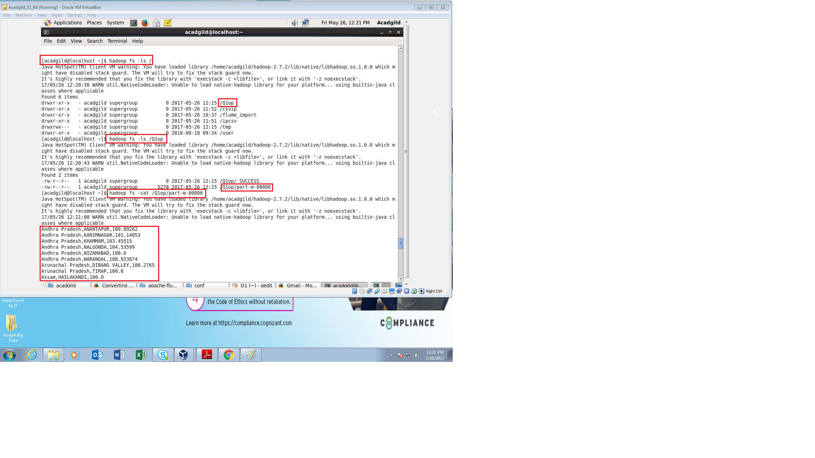

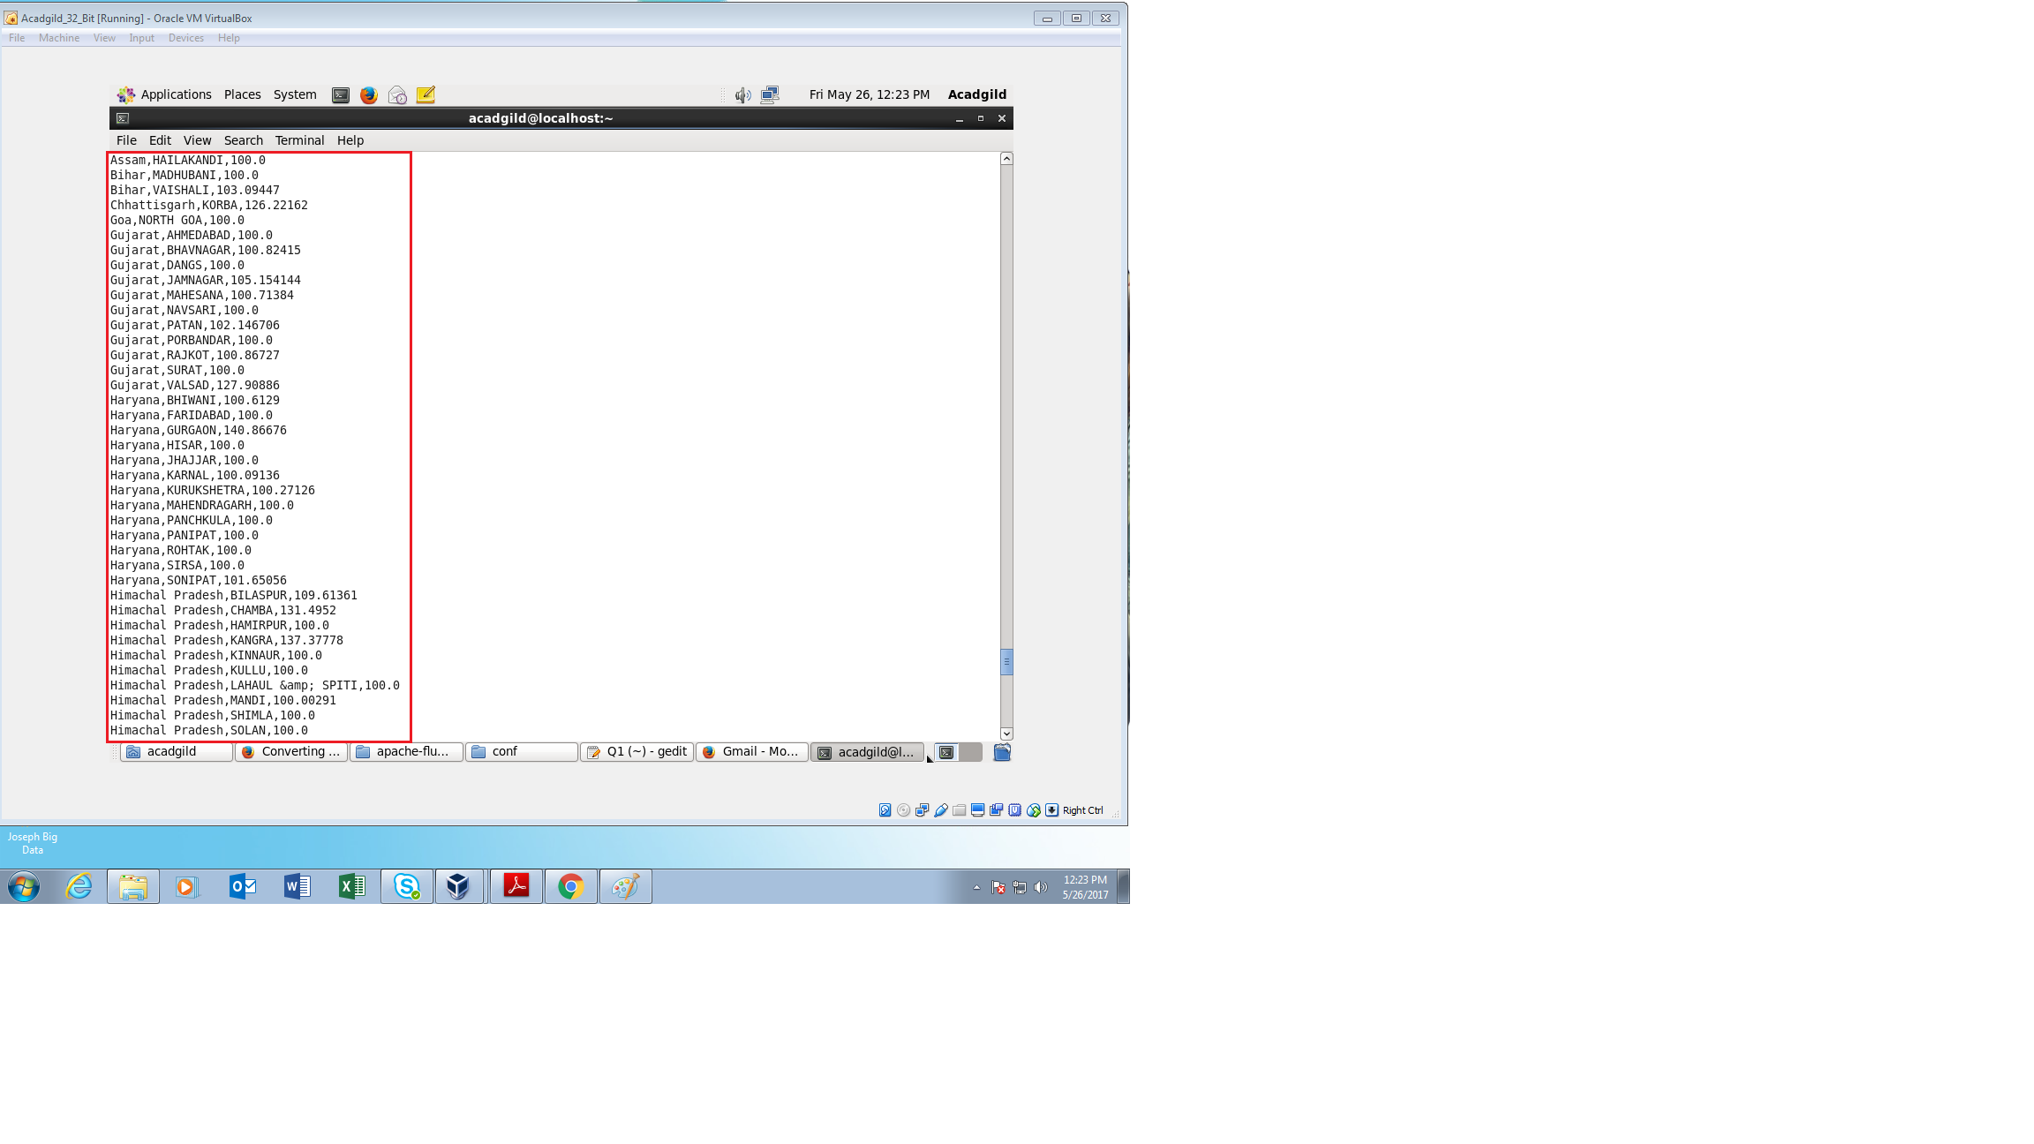 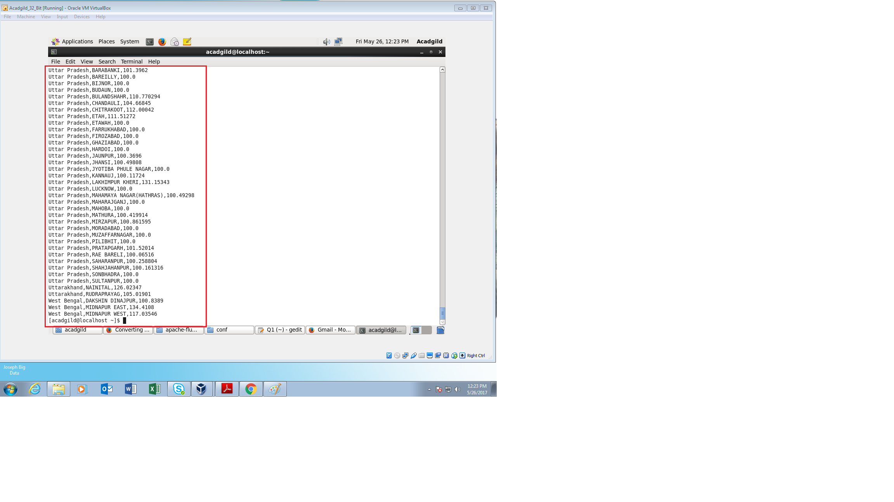

From above we can see that the input data is present in HDFS.

Since the data set is very large, only the beginning and the end of the fetch results are attached.

**Exporting data from HDFS to MYSQL using SQOOP:**

First the SQL server is started in the terminal and a database is created for exporting the input data from HDFS

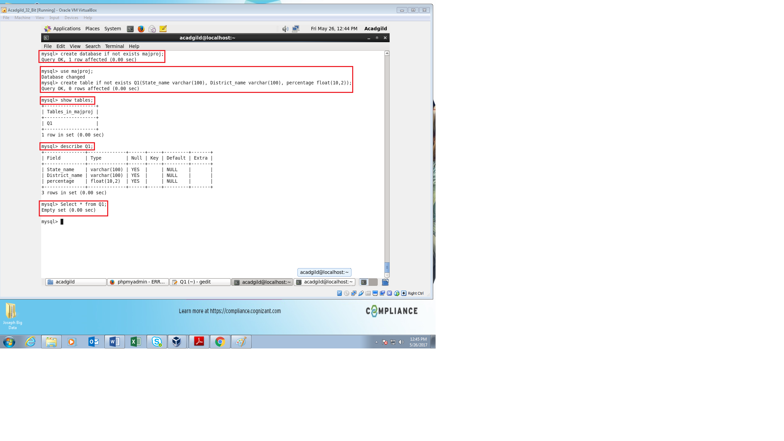

From the above image we can see that the database **majproj** and table **Q1** is created and there are no data inside denoting that the input data is not exported into MYSQL.

The following command is run for exporting the input data from HDFS to MYSQL

**Command** : sqoop export --connect jdbc:mysql://localhost/majproj --username root --password acadgild --table Q1 --export-dir /sqqop/

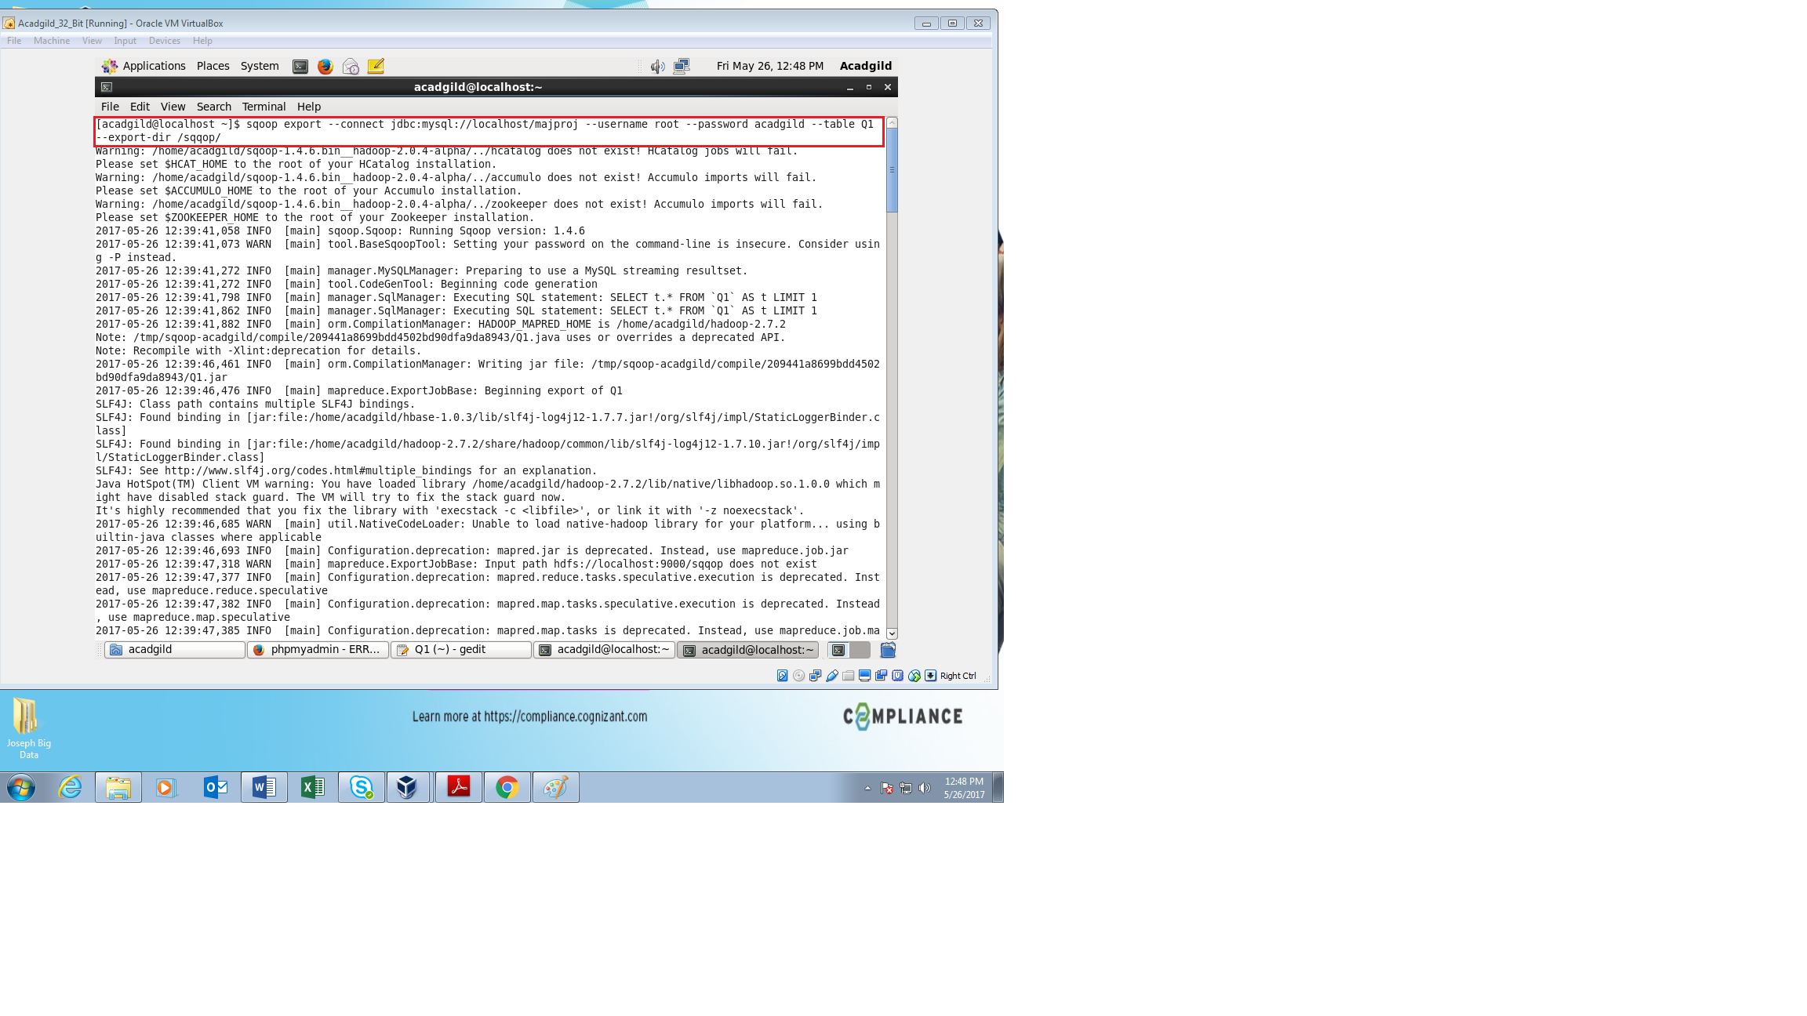

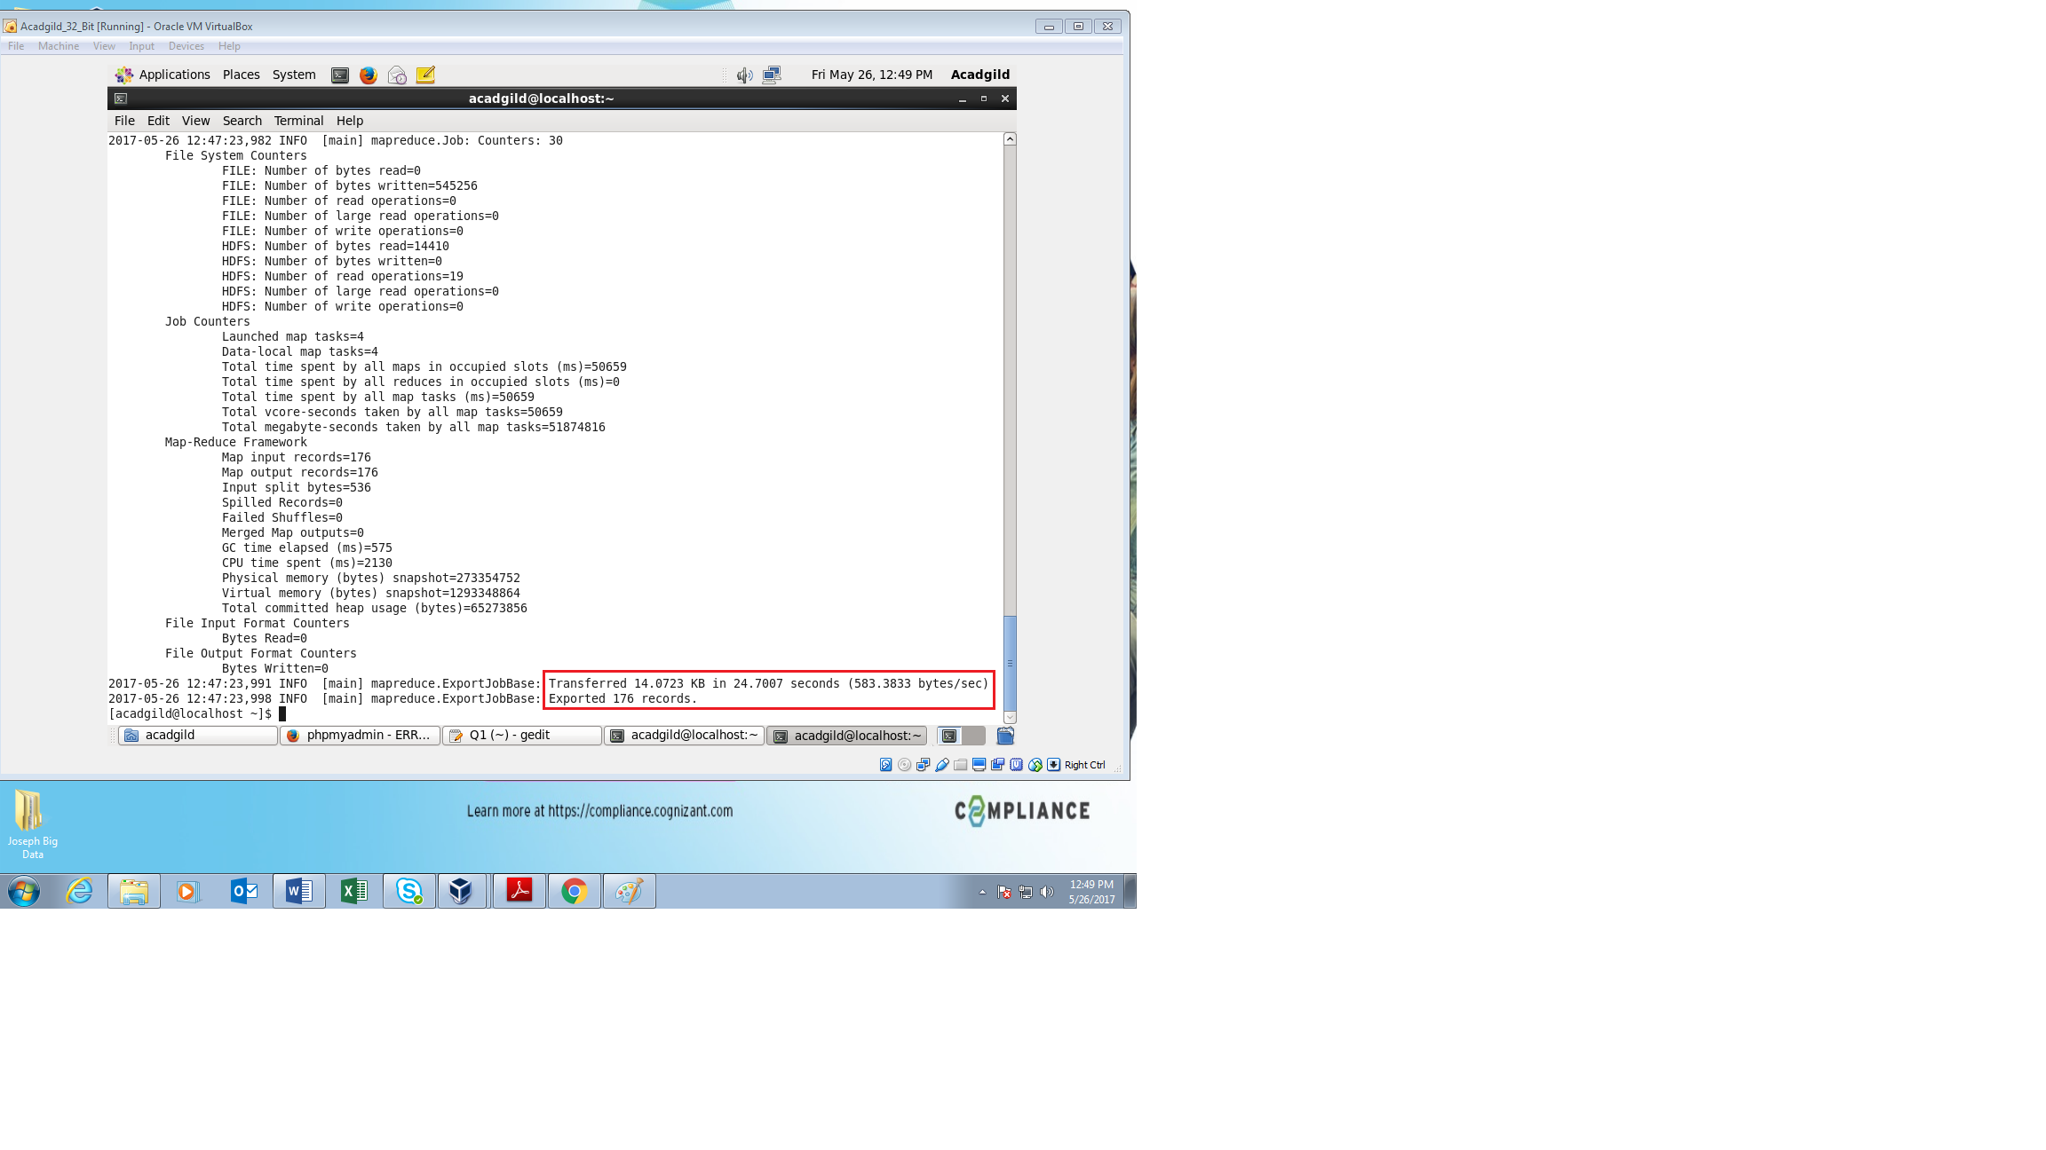

From the above image it shows that the required records are exported from the HDFS to MYSQL.

The output can be checked for the achieved records in the MYSQL server as follows

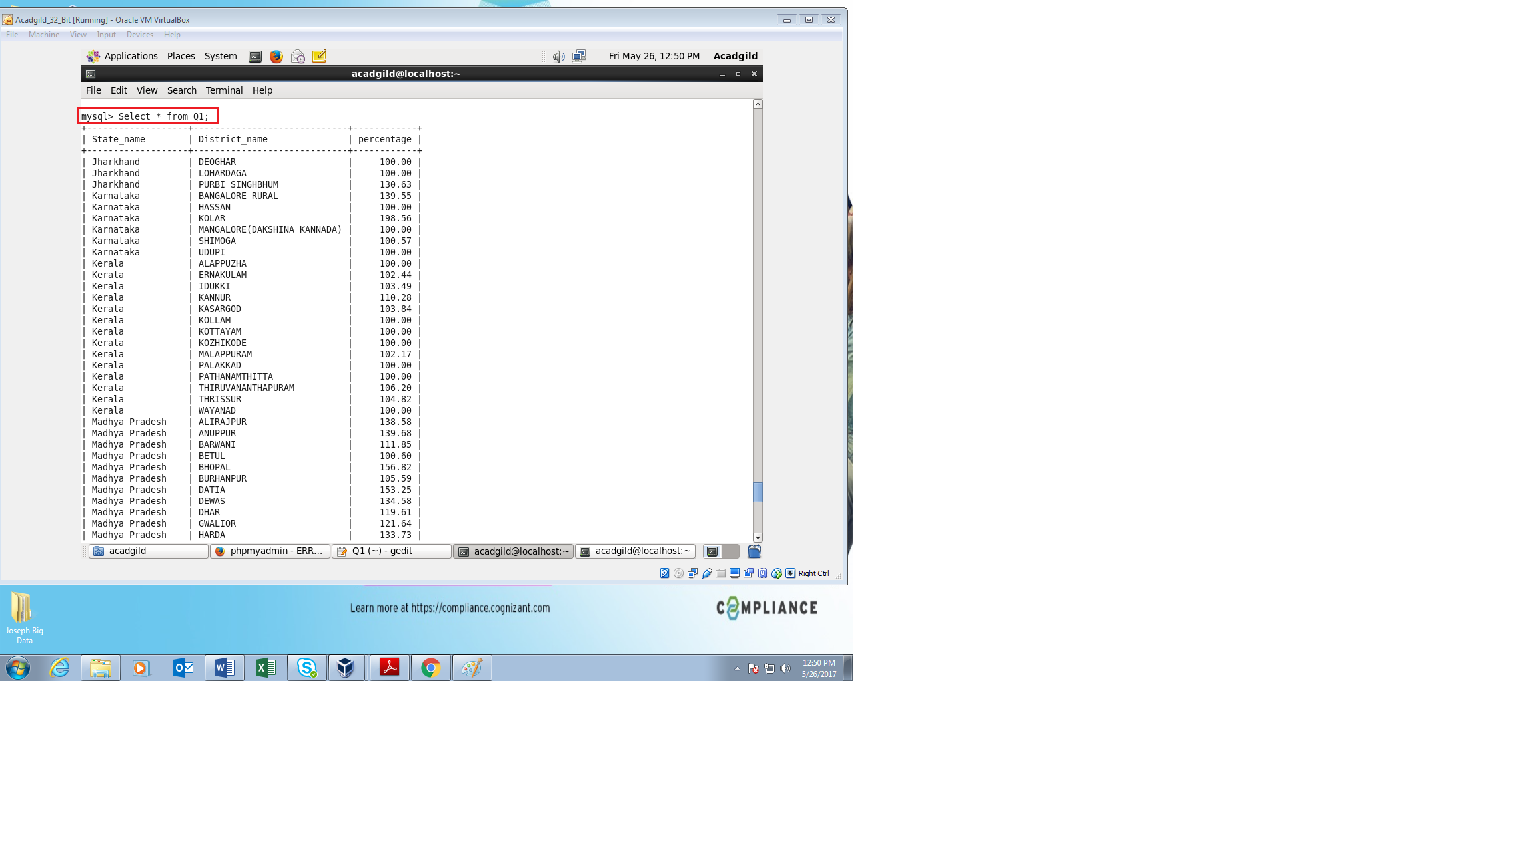

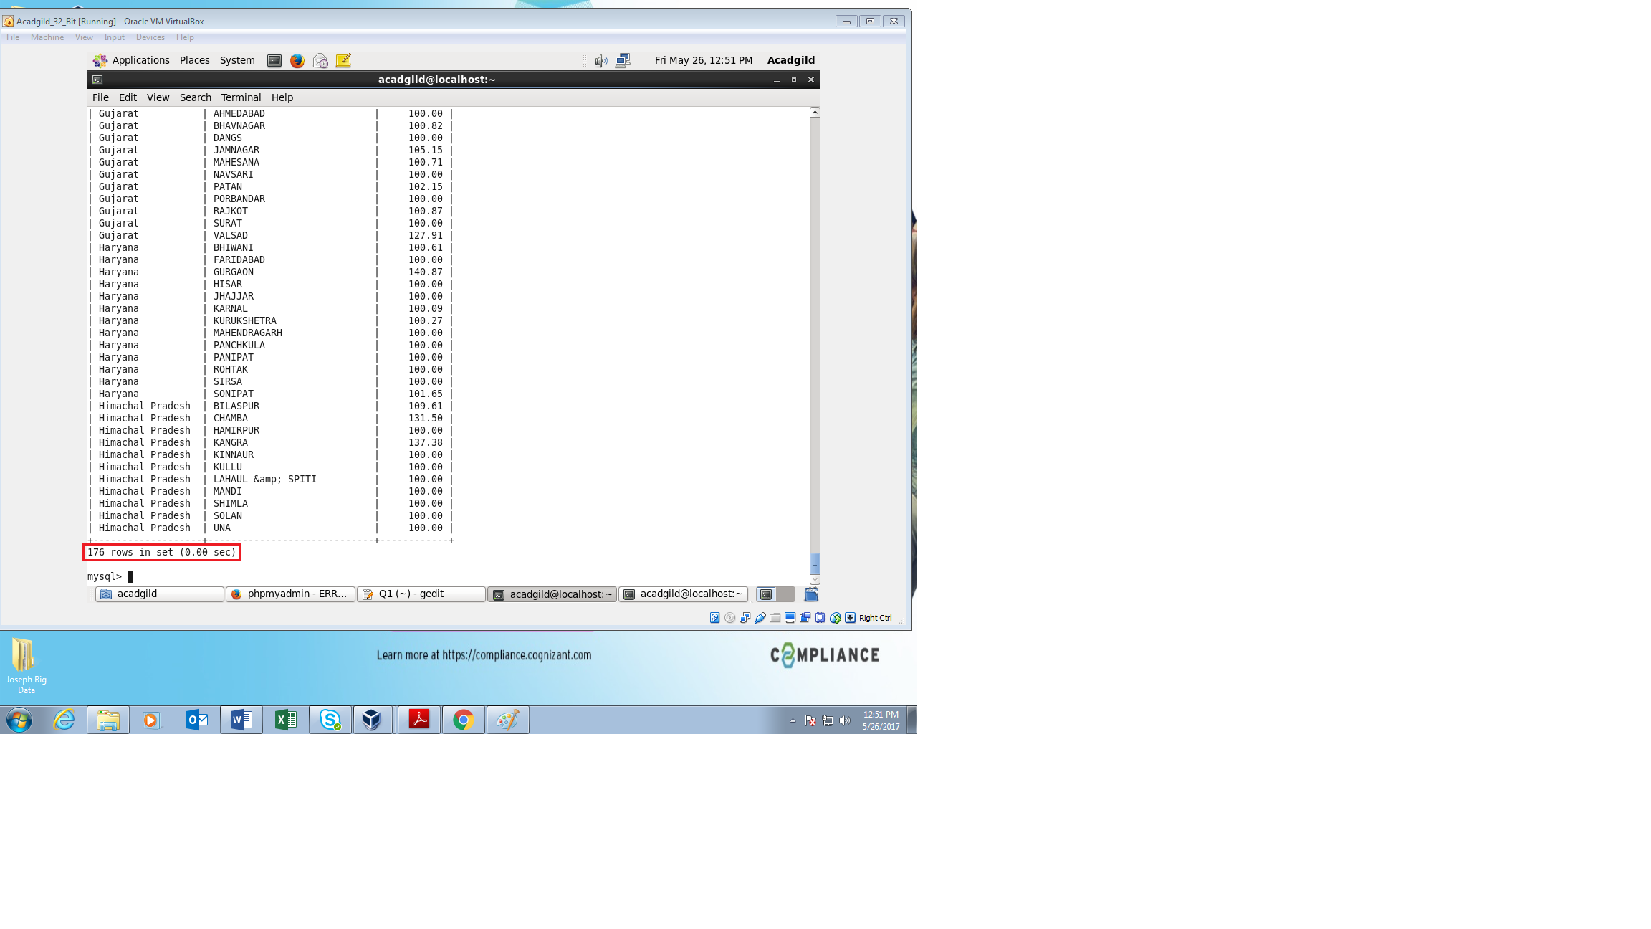

From the above images we can see that the input data from HDFS has been successfully exported into MYSQL using SQOOP.

Since the output is very large, only the beginning and ending of the fetched results are attached.

The total rows fetched are highlighted to give the result obtained and required.

**Problem Statement 2:**

* Write a Pig UDF to filter the districts which have reached 80% of objectives of BPL cards.
* Export the results to MySQL using Sqoop.

**Solution:**

The requirement for the problem statement is to find which districts have achieved 80% objective in BPL cards and the achieved result should be exported to mysql using SQOOP.

The program is written in PigScript using Shell Scripting methods for easy understanding and to reduce the complexity of programming

The program also has a UDF to filter the requirements.

**PigScript:**

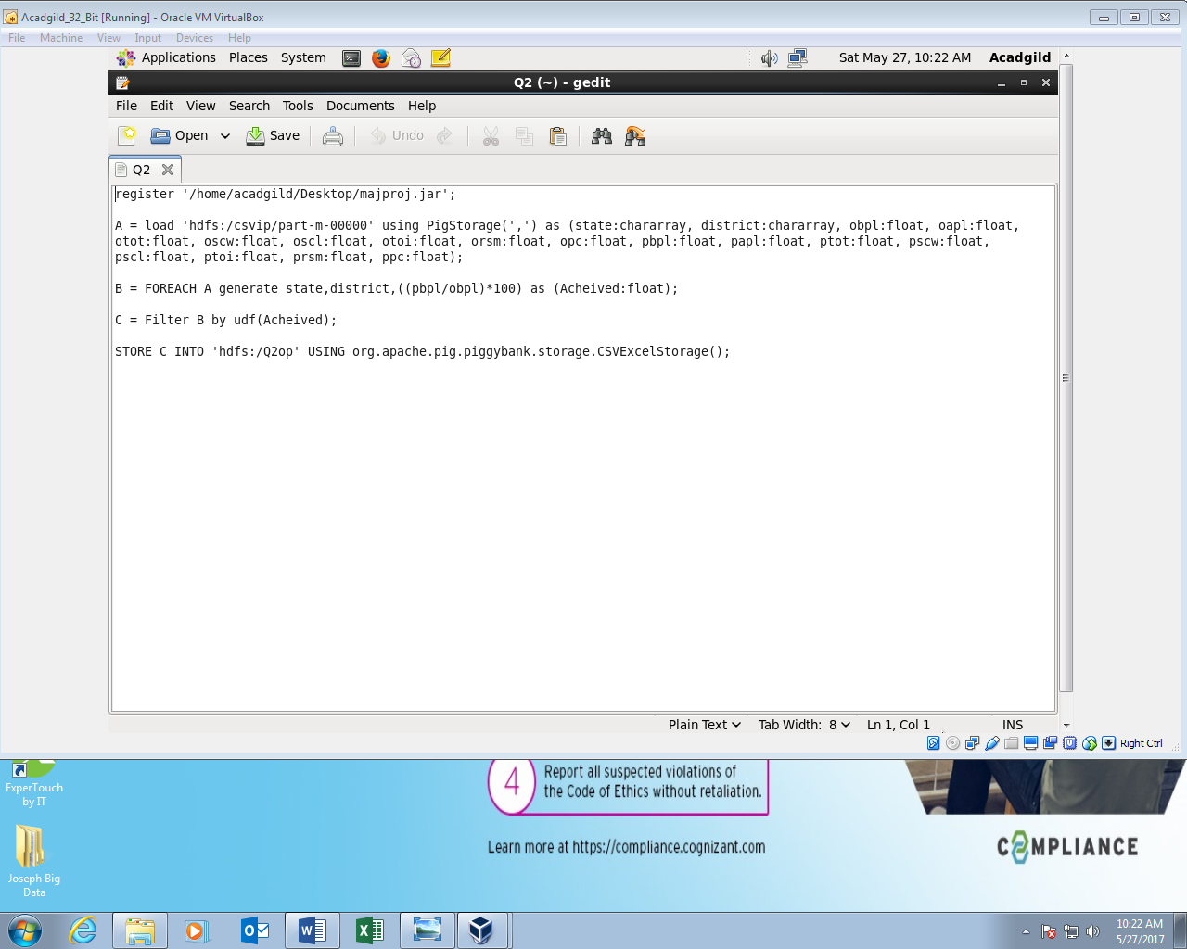

**The PigScript is explained as follows:**

First the command **register ‘/home/acadgild/Desktop/majpoj.jar’;**  is done in order to export the jar file (UDF).

**Step A:**

The part file of the input is loaded using PigStorage and the dataset is separated by comma ( , ). The data set is defined in this step based on the input given and output required.

**Step B:**

From the problem statement, it is required to calculate the percentage of the required dataset.

Hence the required columns are taken and the percentage is calculated for all the records for the given columns taken.

**Step C:**

Since the filter is done in the UDF, Step C displays the results achieved from the UDF script

Finally, the result from Step C is stored into HDFS under the file Q2op.

**UDF:**

The UDF script gives the condition for filtering the requirements for the problem.

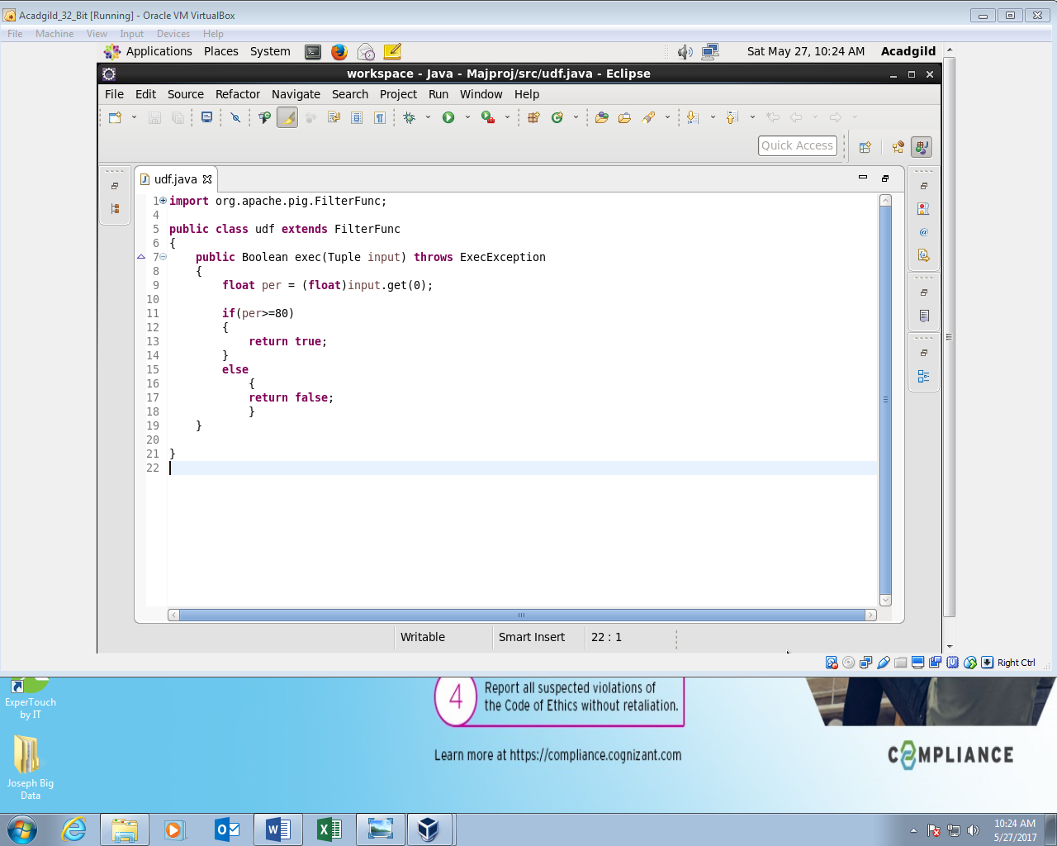

In this we can see that the requirements of the problem is executed in the UDF script and is passed to filter out the required results when executed.

After the PigScript is completed, the Pigscript is run in the terminal by following sequence

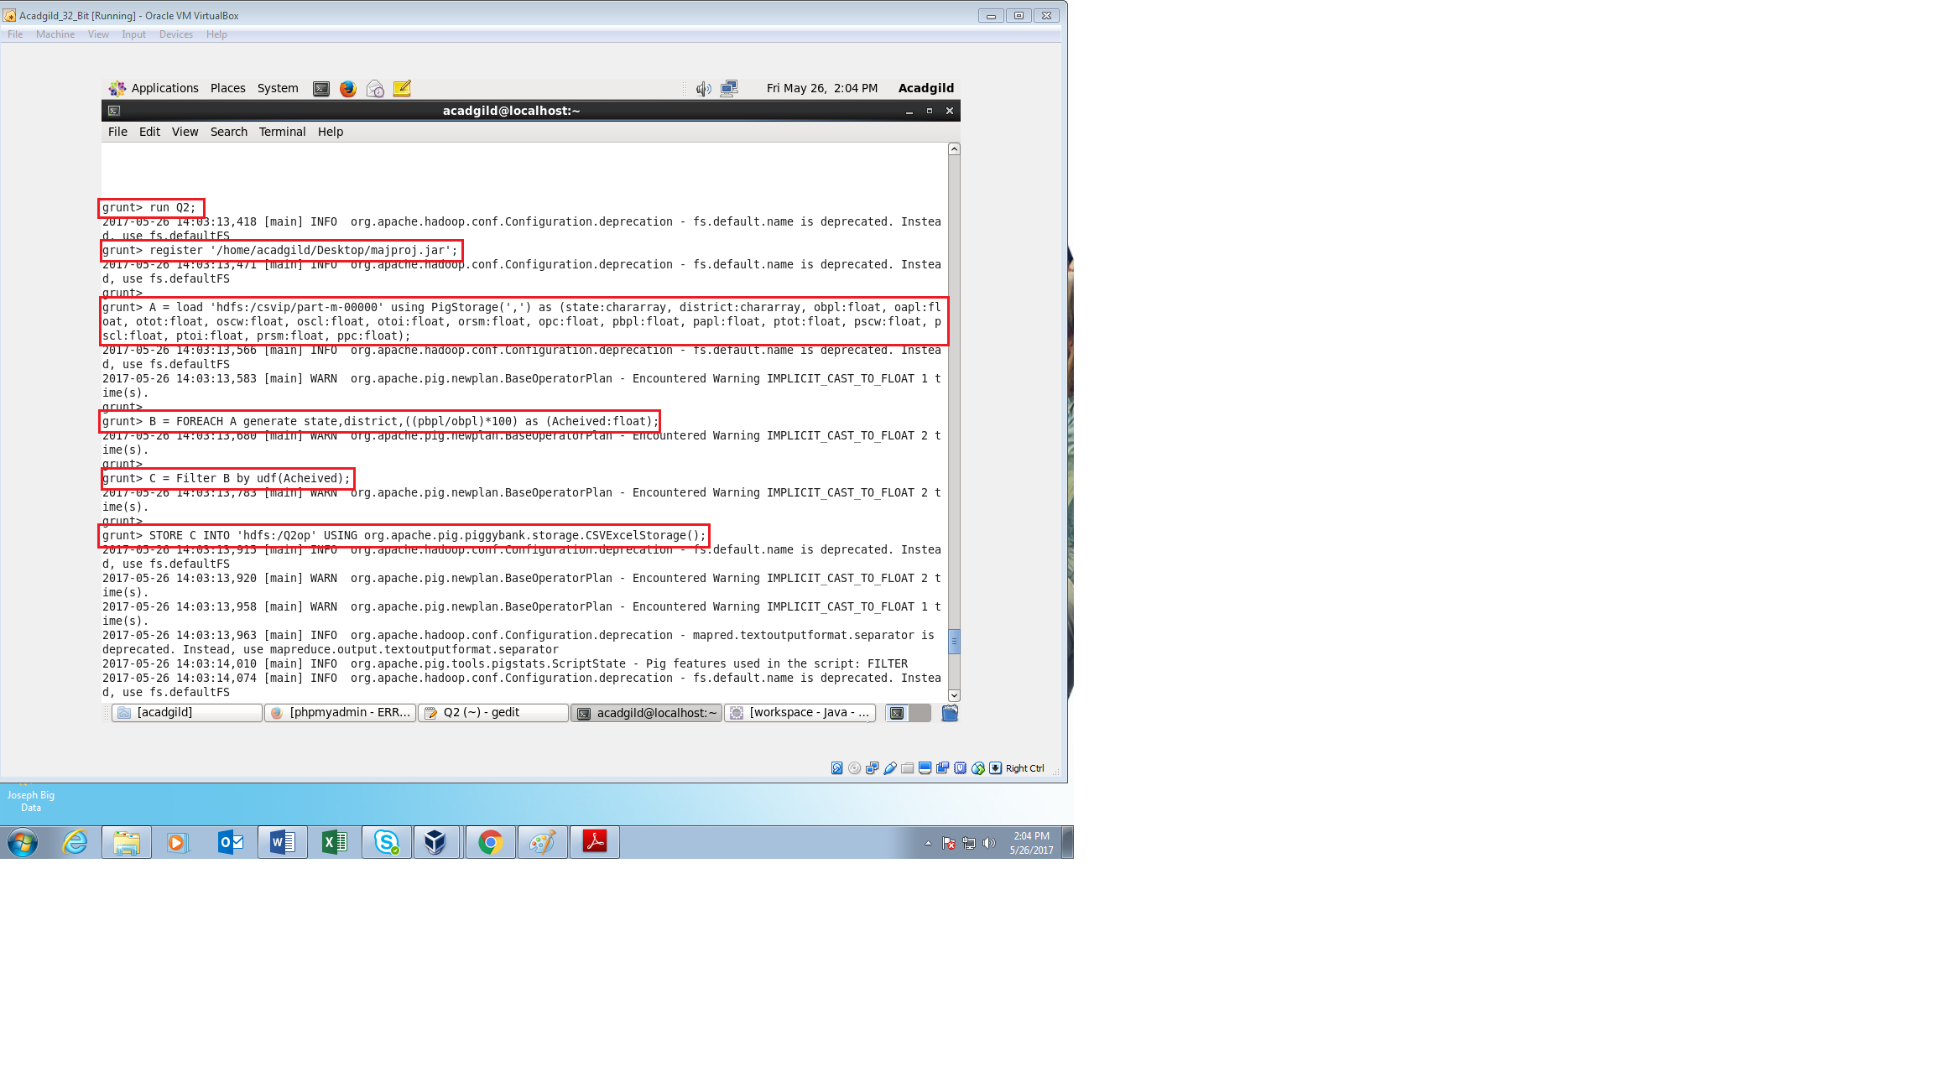

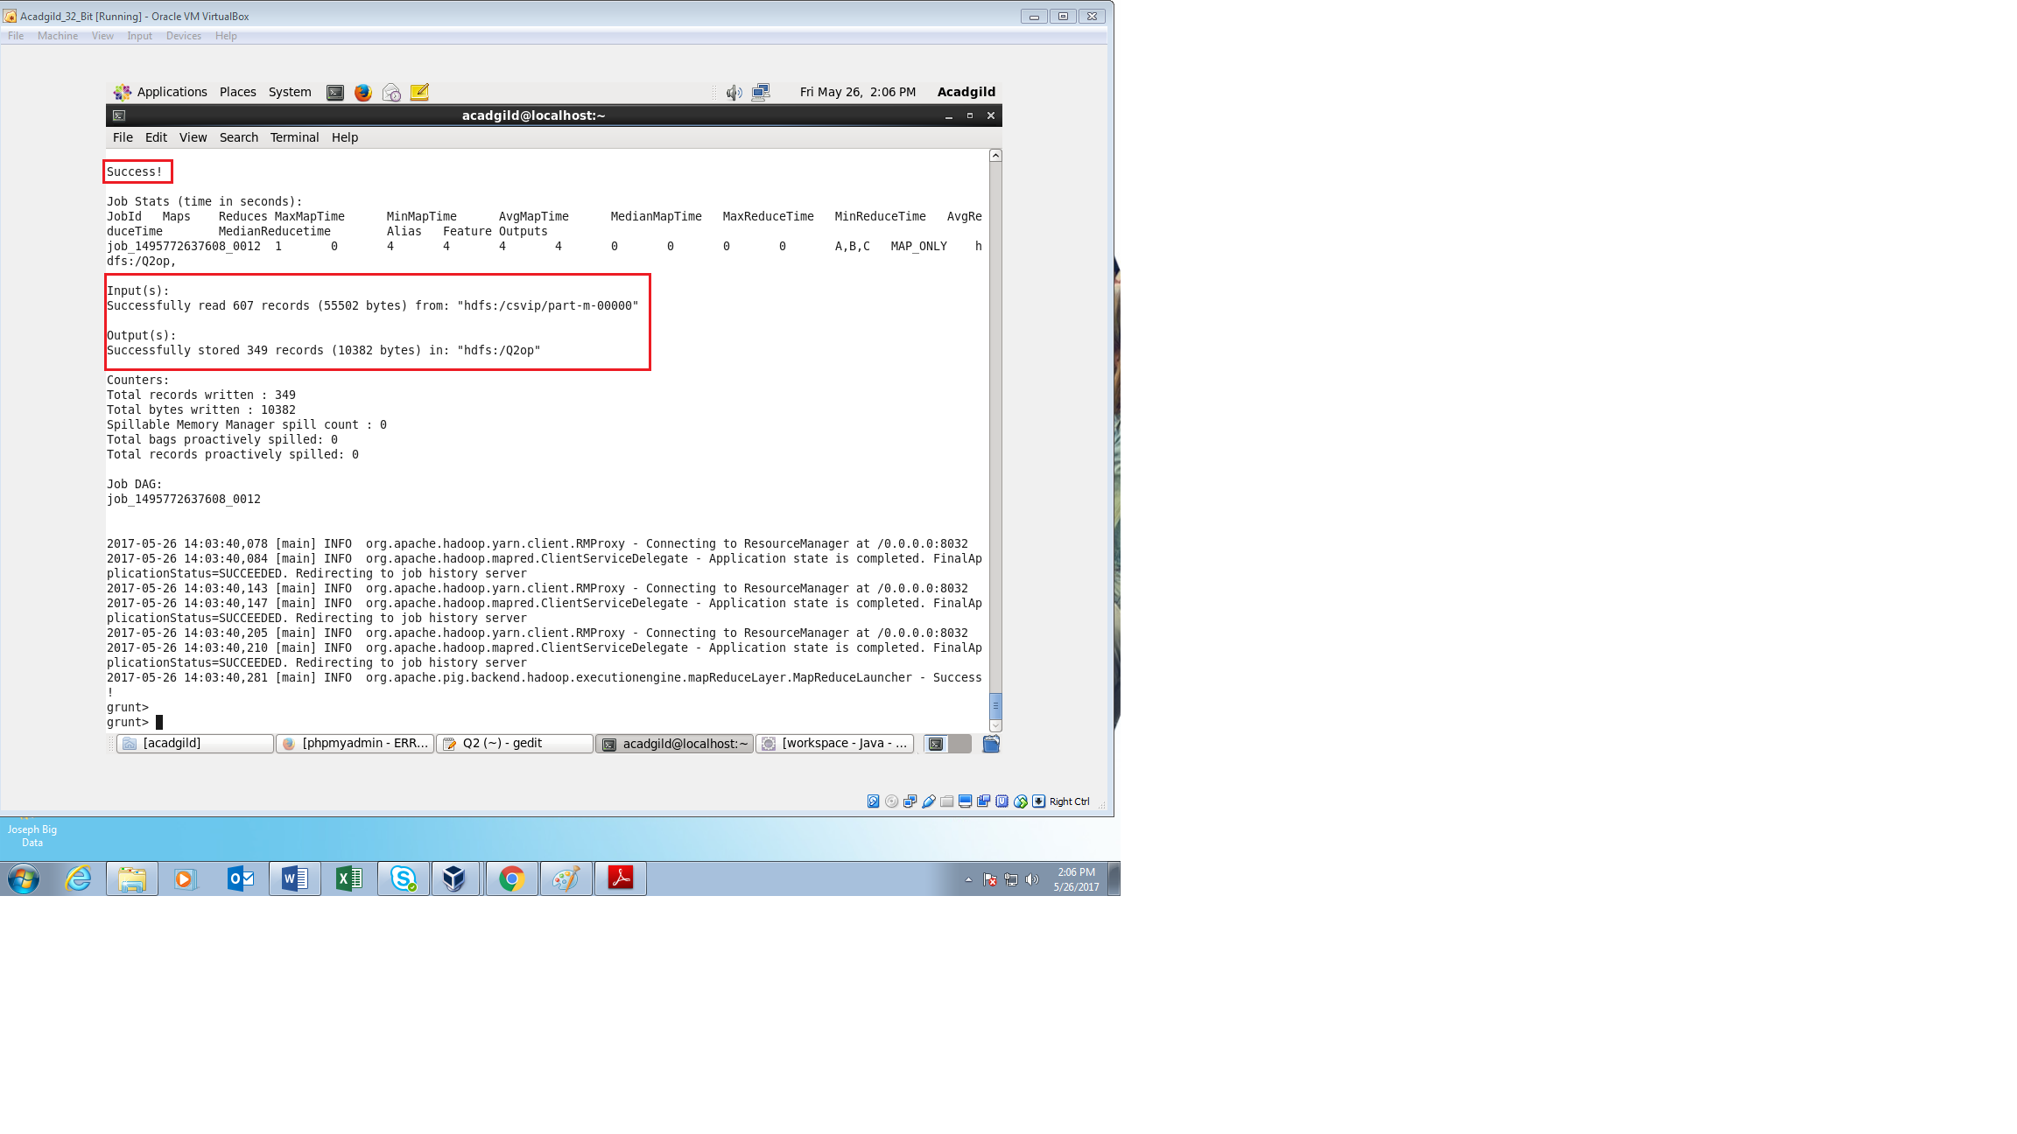

After successfully running the PigScript, The following steps are executed to check if the data set is present in HDFS

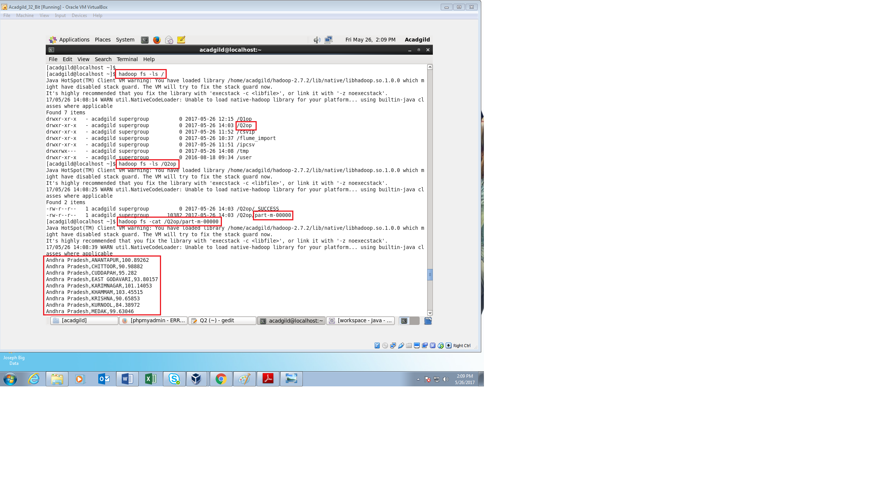

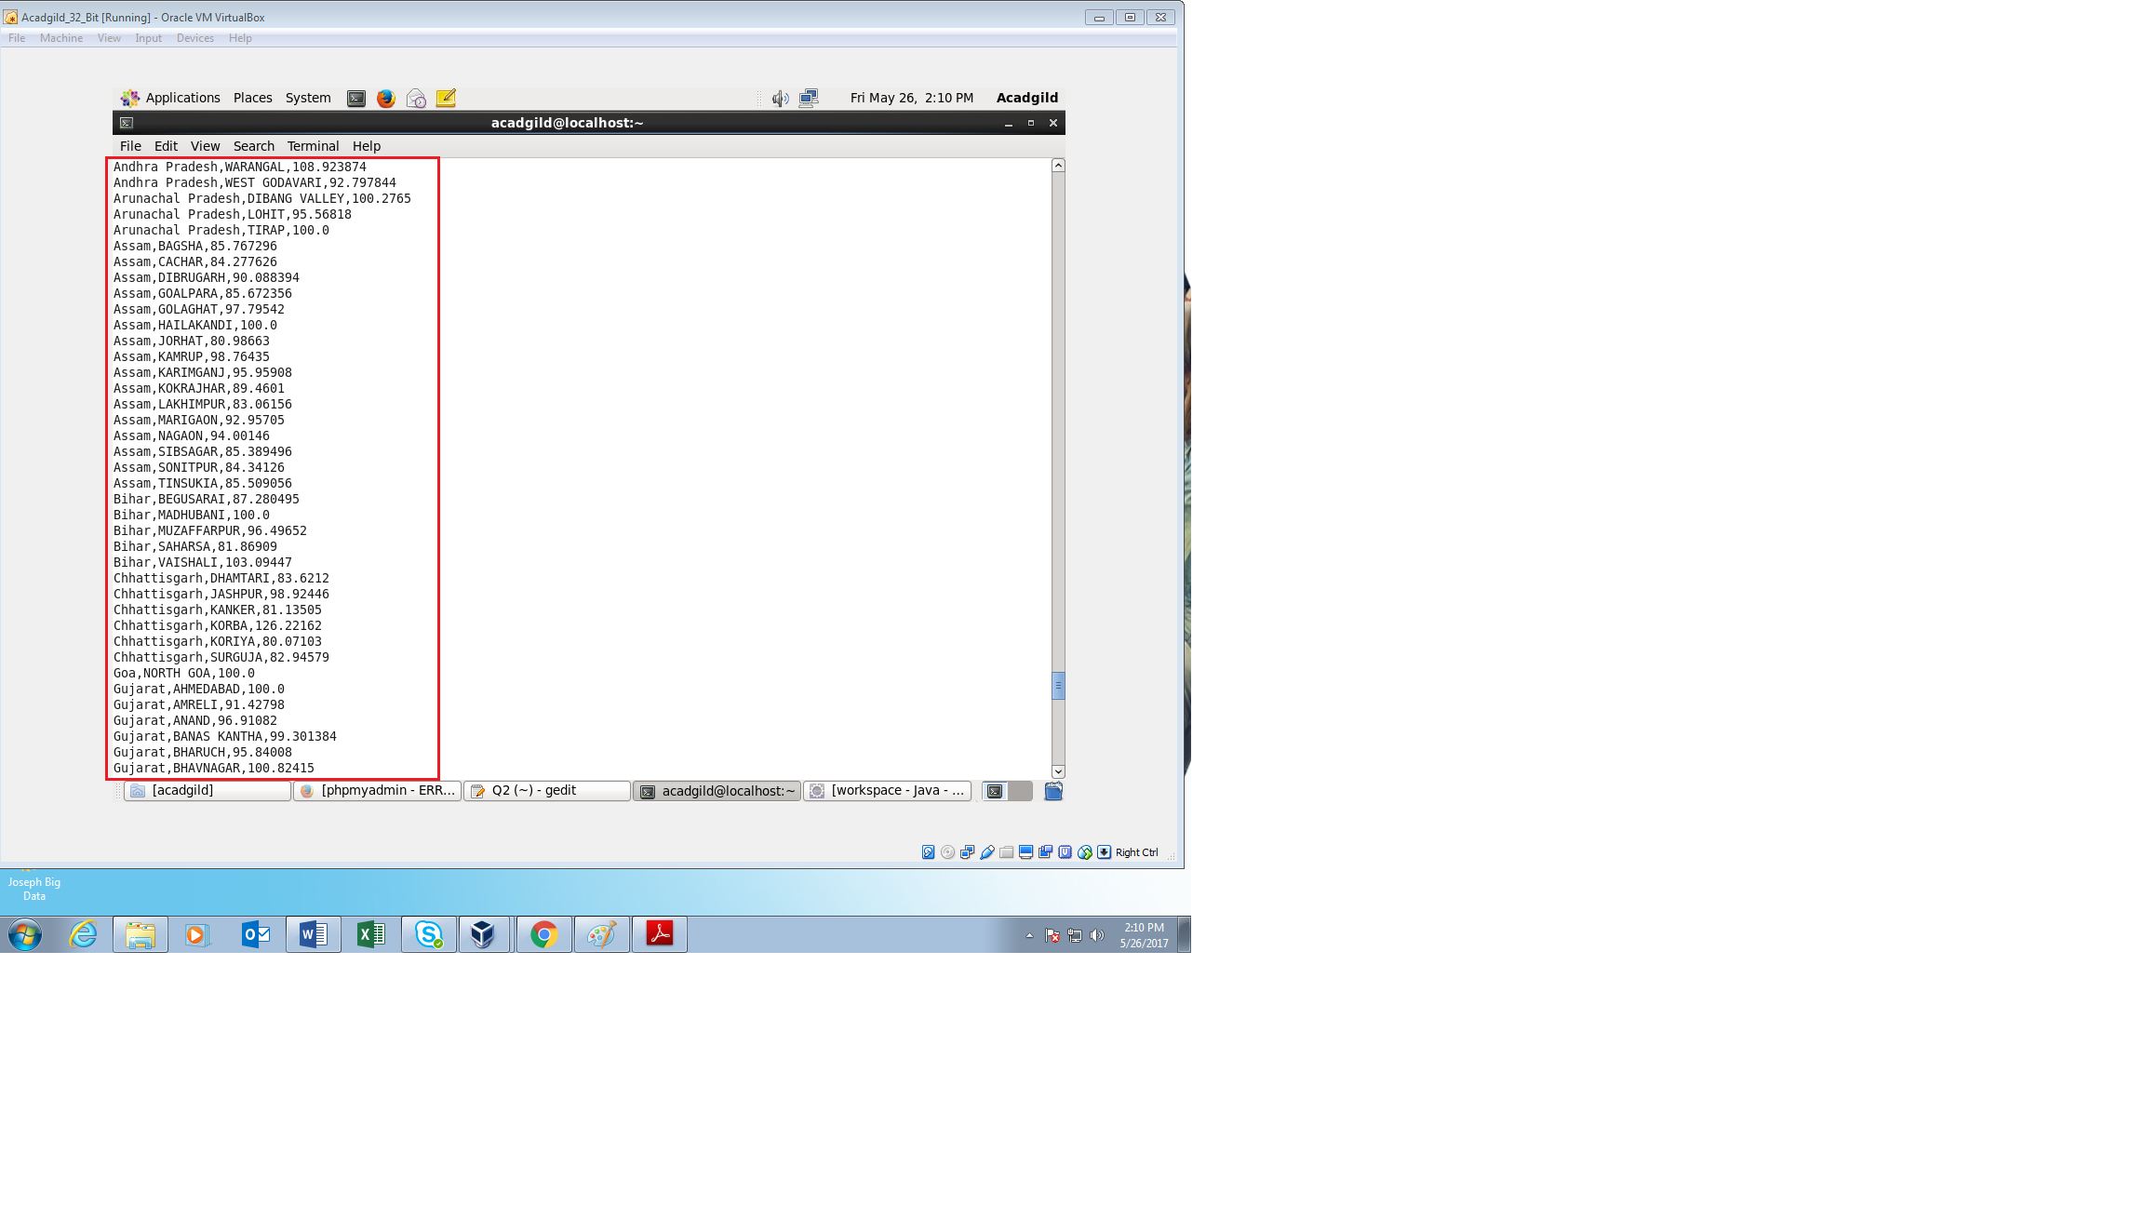

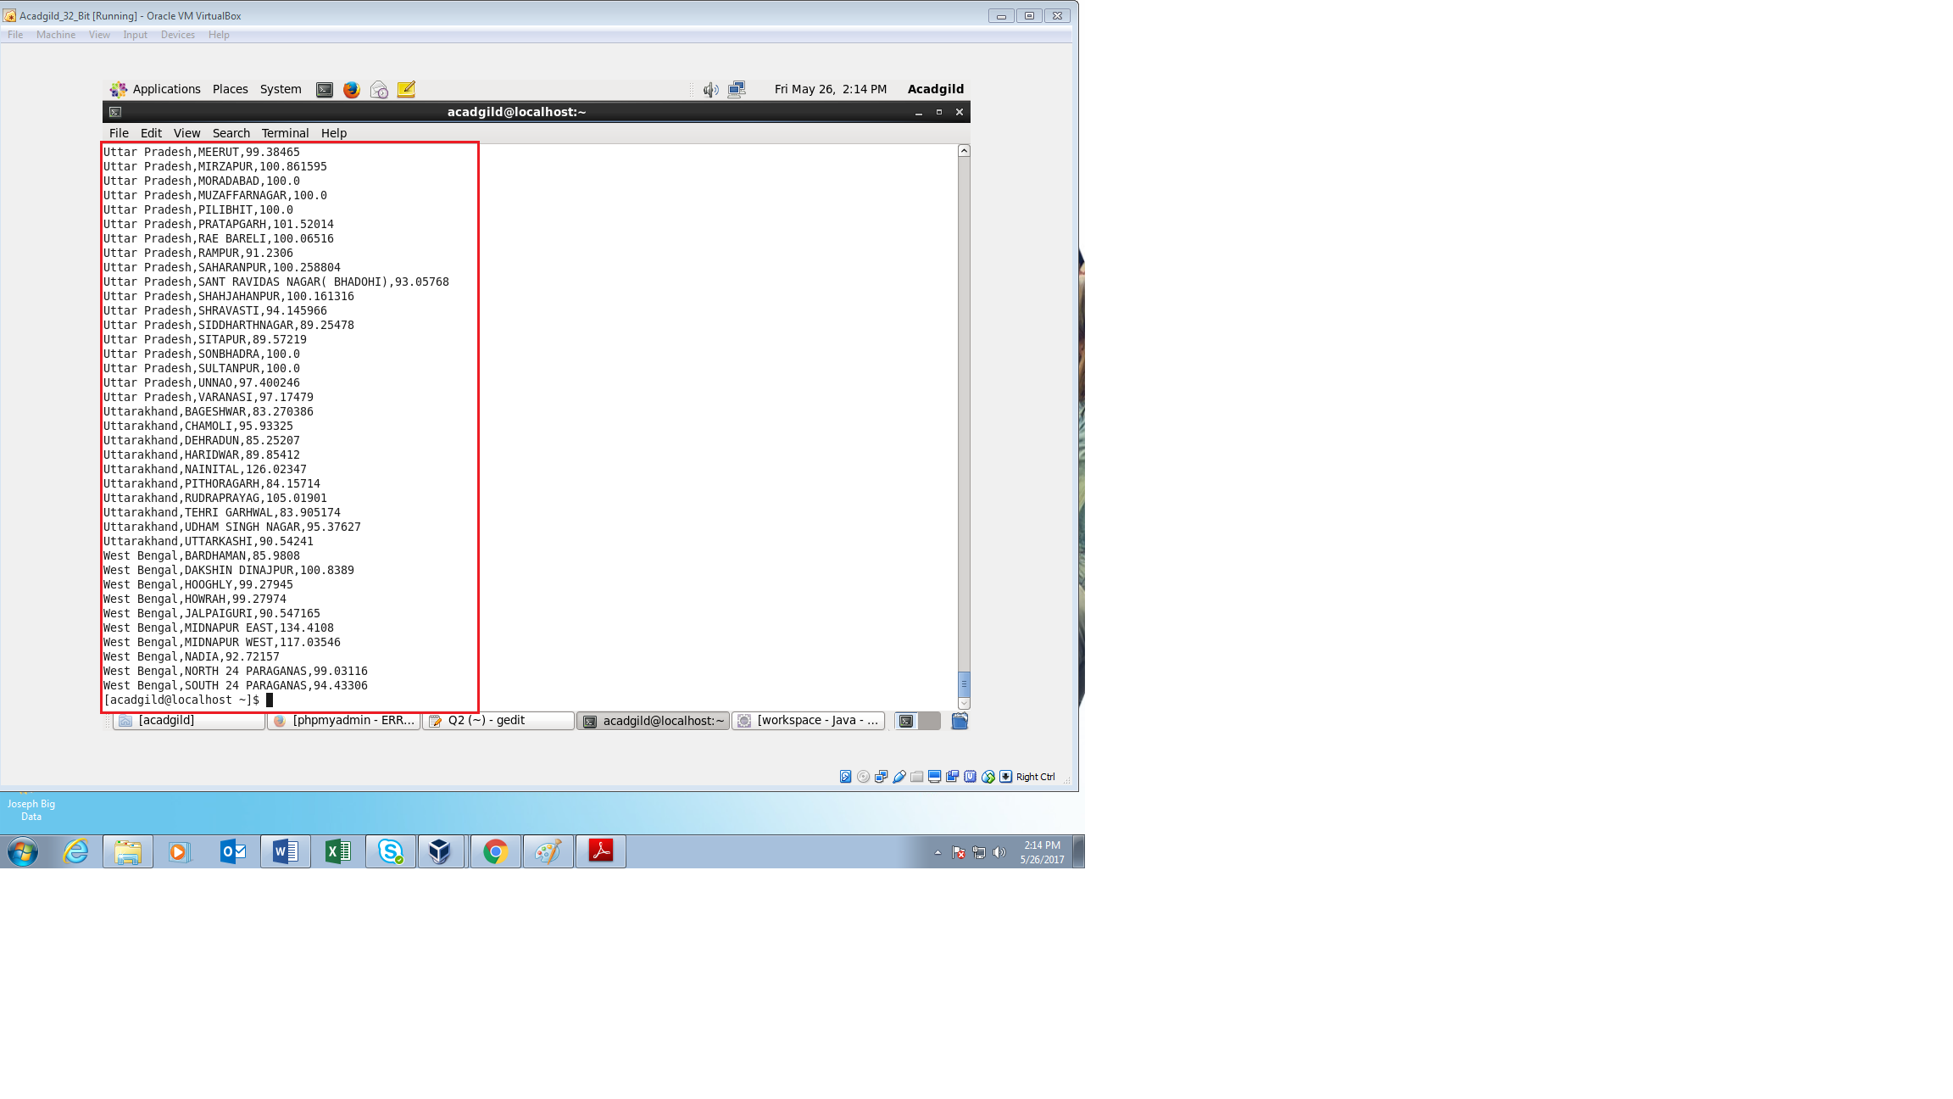

From above we can see that the input data is present in HDFS.

Since the data set is very large, only the beginning and the end of the fetch results are attached.

**Exporting data from HDFS to MYSQL using SQOOP:**

First the SQL server is started in the terminal and a database is created for exporting the input data from HDFS

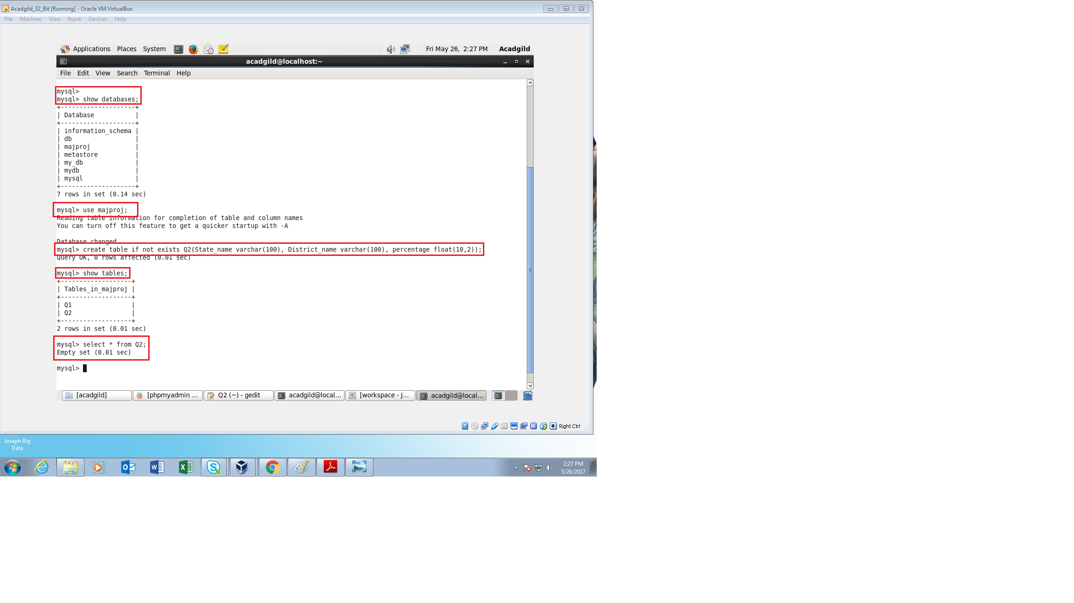

From the above image we can see that the database **majproj** and table **Q2** is created and there are no data inside denoting that the input data is not exported into MYSQL.

The following command is run for exporting the input data from HDFS to MYSQL

**Command** : sqoop export --connect jdbc:mysql://localhost/majproj --username root --password acadgild --table Q2 --export-dir /sqqop/

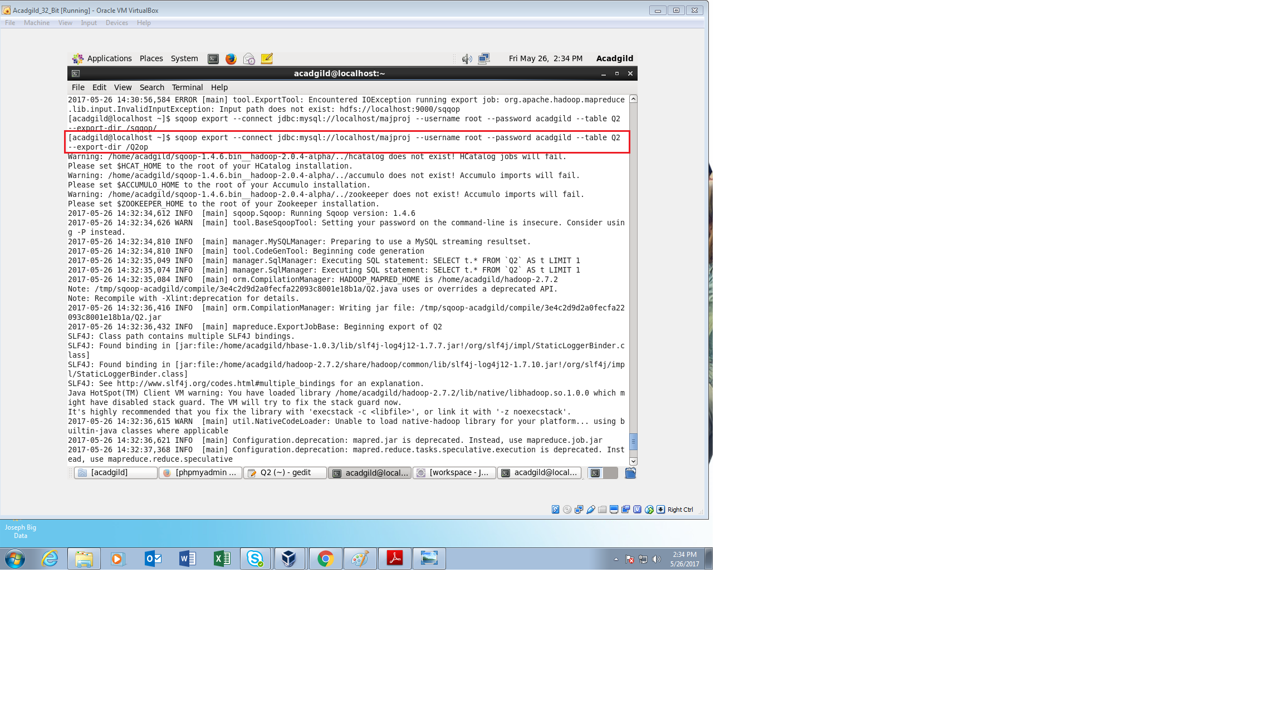

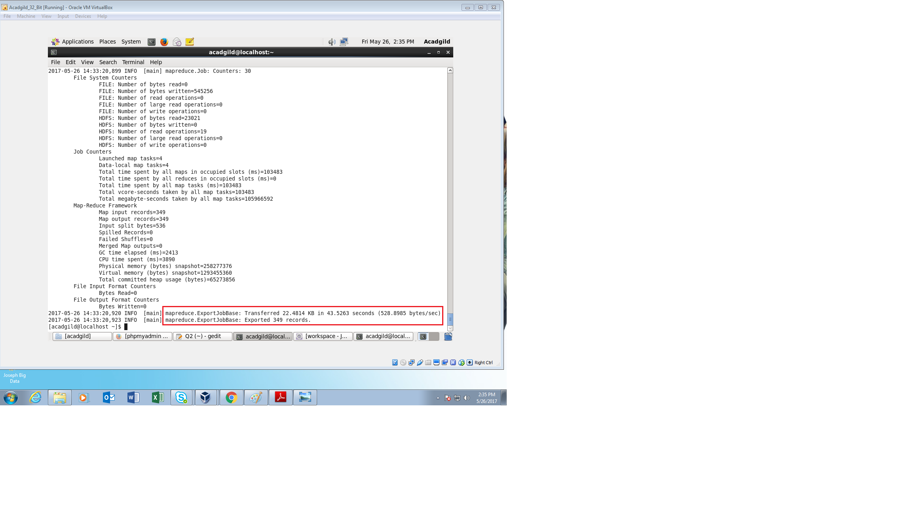

From the above image it shows that the required records are exported from the HDFS to MYSQL.

The output can be checked for the achieved records in the MYSQL server as follows

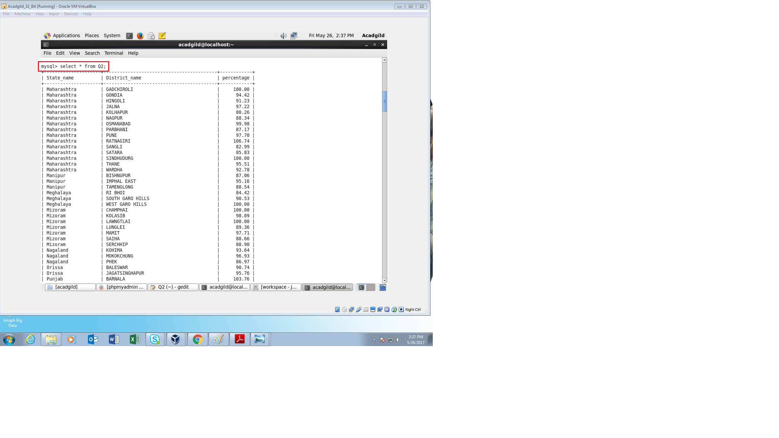

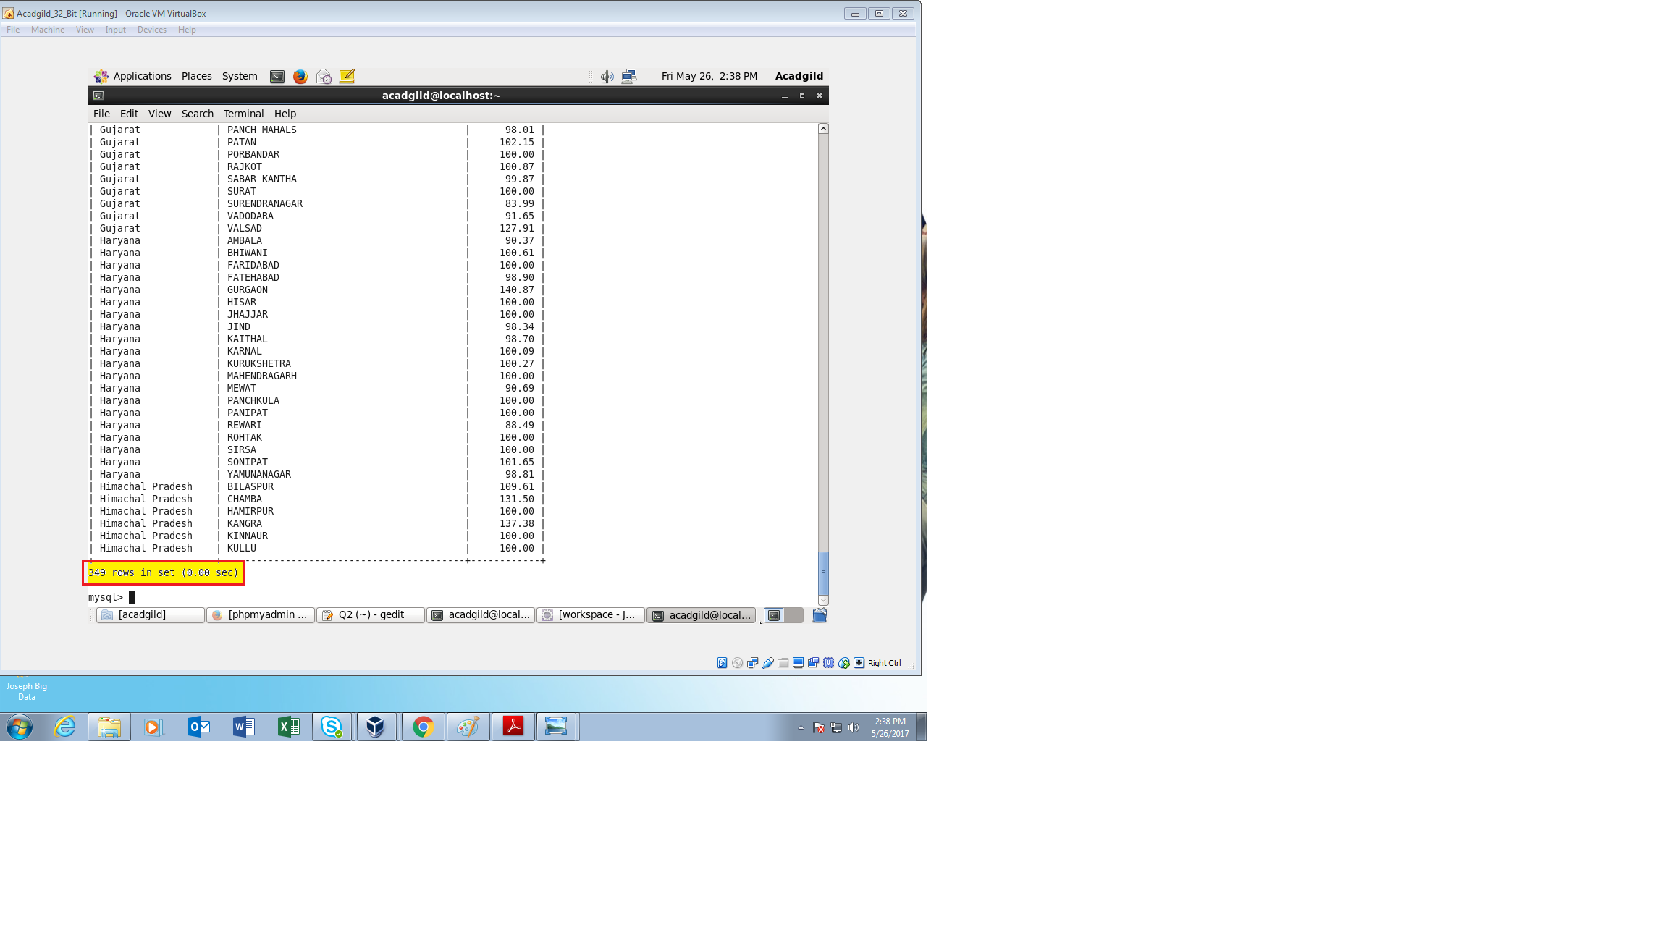

From the above images we can see that the input data from HDFS has been successfully exported into MYSQL using SQOOP.

Since the output is very large, only the beginning and ending of the fetched results are attached.

The total rows fetched are highlighted to give the result obtained and required.

**Conclusion:**

The following are the conclusions obtained from the given project:

* The System to analyze the log data (In XML format) of government progress of various development activities is developed
* The purpose of this project to capture the data for analyzing the progress of various activities is satisfied
* The requirements of the problem statements were successfully achieved.